LAB1

import java.util.Scanner;

class QuadraticEquations

{

public static void main(String args[])

{

double a,b,c,D;

double r1,r2;

Scanner in = new Scanner(System.in);

System.out.println("Enter the constants a,b and c of the quadratic equation a(x)^2+b(x)+c=0 : ");

a = in.nextDouble();

b = in.nextDouble();

c = in.nextDouble();

System.out.println();

System.out.println("Input Quadration Equation : "+a+"(x)^2 + "+b+"(x) + "+c+" = 0");

System.out.println();

D = (b*b)-(4*a*c);

if(D>0)

{

System.out.println("Roots are real and unequal since Discriminant = "+D);

r1 = (-b + Math.sqrt(D))/(2*a);

r2 = (-b - Math.sqrt(D))/(2*a);

System.out.println();

System.out.println("Roots of the quadratic equation are "+r1+" and "+r2);

}

else if(D==0)

{

System.out.println("Roots are real and equal since Discriminant = "+D);

r1 = r2 = (-b)/(2*a);

System.out.println();

System.out.println("Roots of the quadratic equation are "+r1+" and "+r2);

}

else

{

System.out.println();

System.out.println("Roots are unreal since Discriminant = "+D);

}

}

}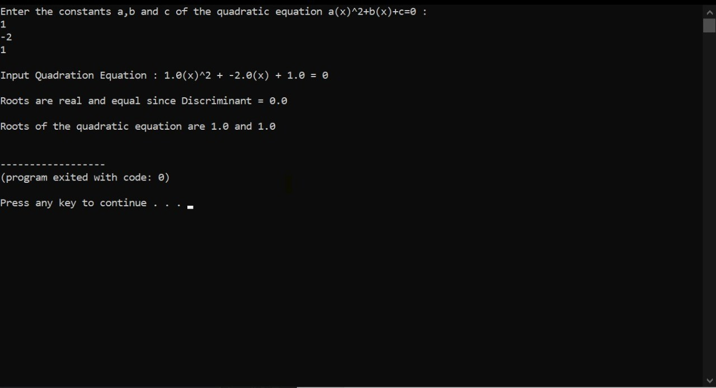

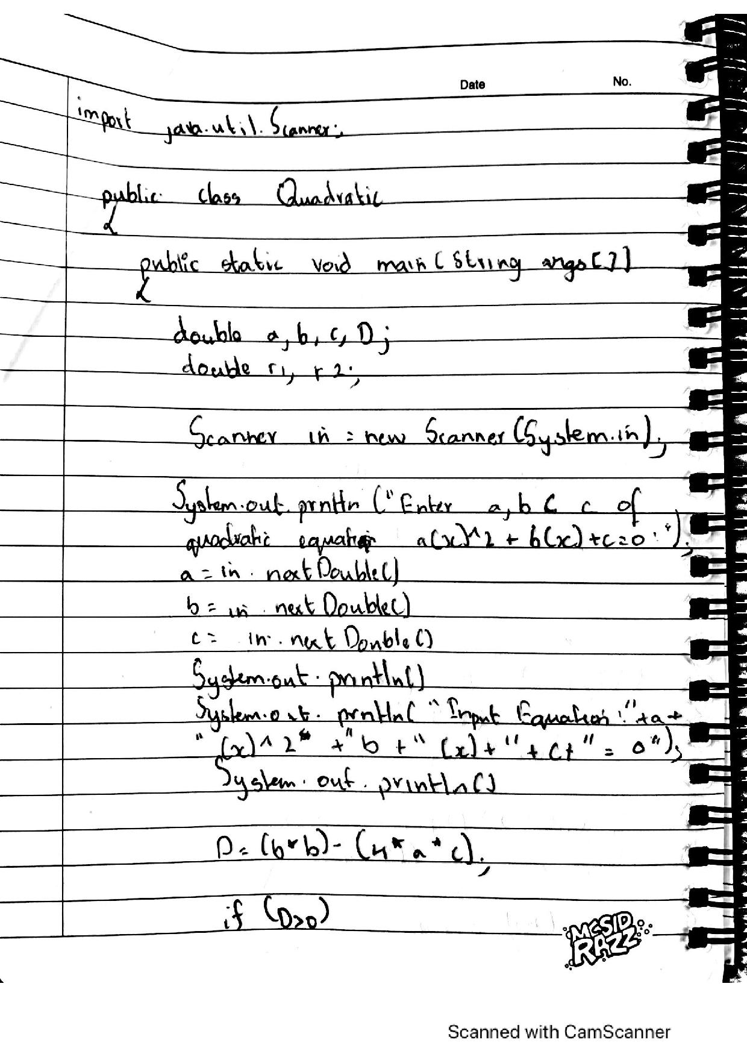

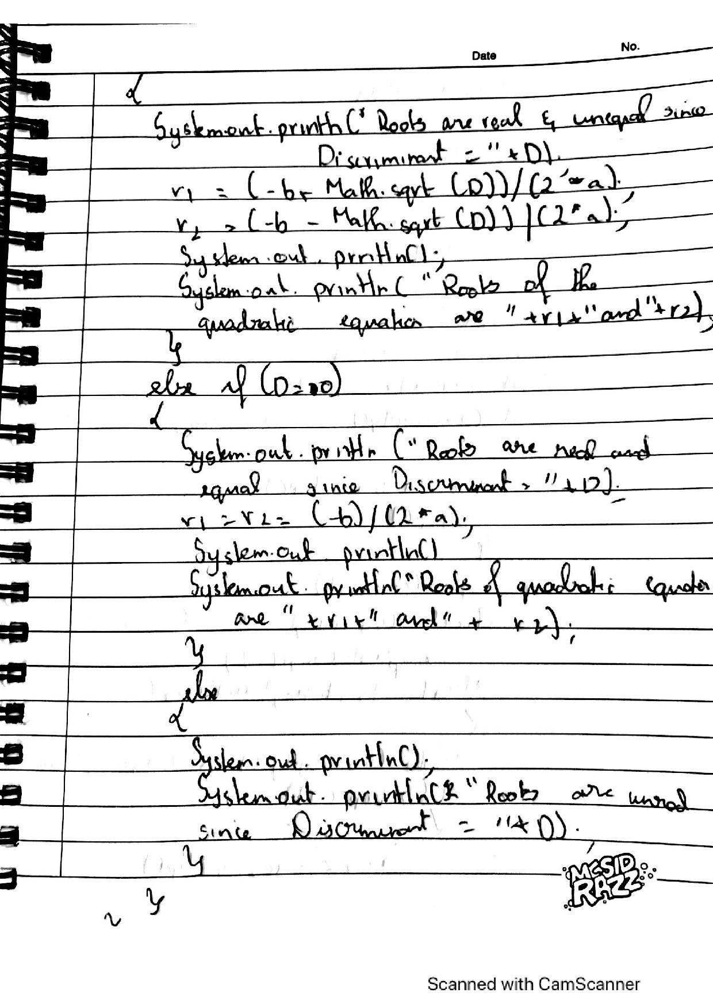

LAB 2

import java.util.Scanner;

class Student{

Scanner sc = new Scanner(System.in);

String USN;

String Name;

int credits[] = new int[5];

float marks[] = new float[5];

int points[] = new int[5];

float SGPA;

int totalCredits = 0;

void getDetails(){

System.out.println("Enter student USN: ");

USN = sc.nextLine();

System.out.println("Enter student Name: ");

Name = sc.nextLine();

for(int i=0;i<5;i++){

System.out.println("Enter Credits for Subject " + (i+1) + ": ");

credits[i] = sc.nextInt();

totalCredits += credits[i];

System.out.println("Enter Marks for Subject " + (i+1) + ": ");

marks[i] = sc.nextFloat();

}

}

void showDetails(){

System.out.println("Student USN: " + USN);

System.out.println("Enter student name: " + Name);

for(int i=0;i<5;i++){

System.out.println("Subject " + (i+1) + " - Credits: " + credits[i] + " - Marks: " + marks[i]);

}

System.out.println("SGPA of " + Name + " is: " + (float)(SGPA/totalCredits));

}

void calcSGPA(){

for(int i = 0;i<5;i++){

if(marks[i] > 100){

System.out.println("Error: Marks are above 100");

return;

}else if(marks[i] >= 90){

points[i] = 10;

}else if(marks[i] >= 80){

points[i] = 9;

}else if(marks[i] >= 70){

points[i] = 8;

}else if(marks[i] >= 60){

points[i] = 7;

}else if(marks[i] >= 50){

points[i] = 5;

}else if(marks[i] >= 40){

points[i] = 4;

}else{

points[i] = 0;

}

SGPA += (points[i]*credits[i]);

}

}

}

public class program {

public static void main(String args[]) {

Student st1 = new Student();

st1.getDetails();

st1.calcSGPA();

st1.showDetails();

}

}

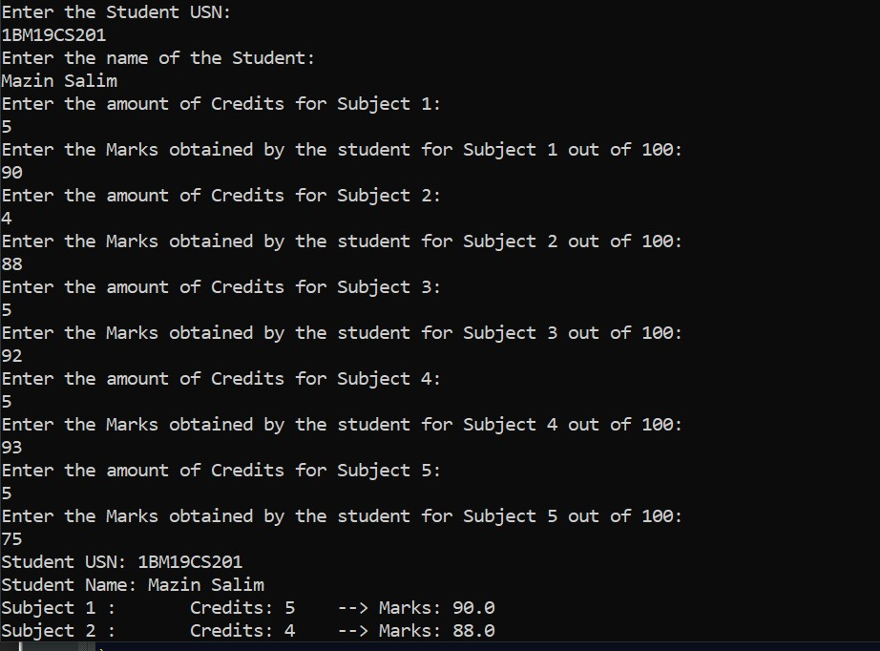

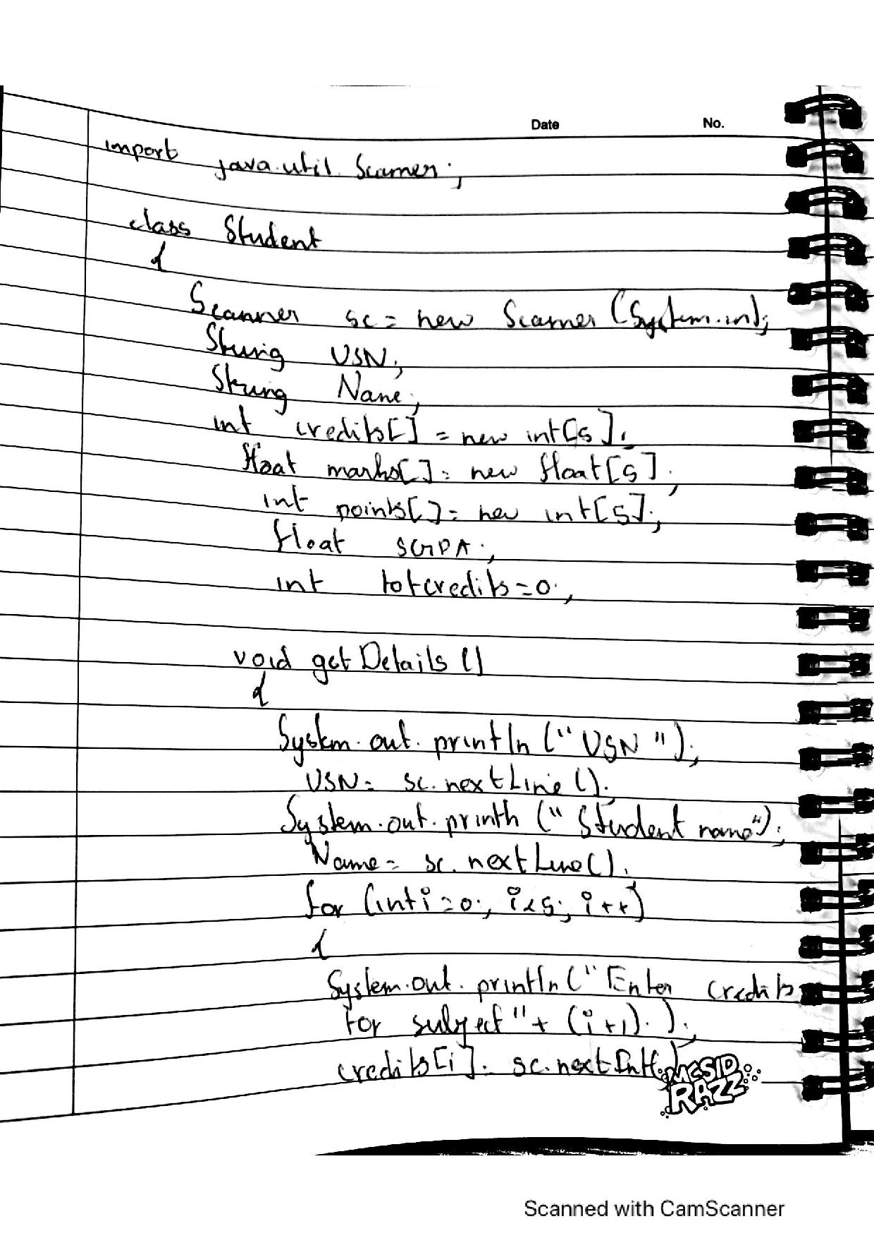

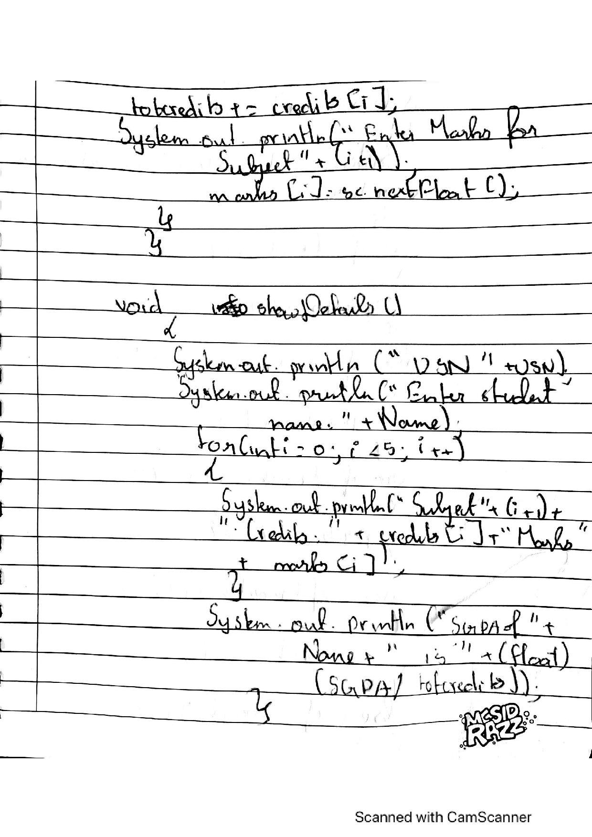

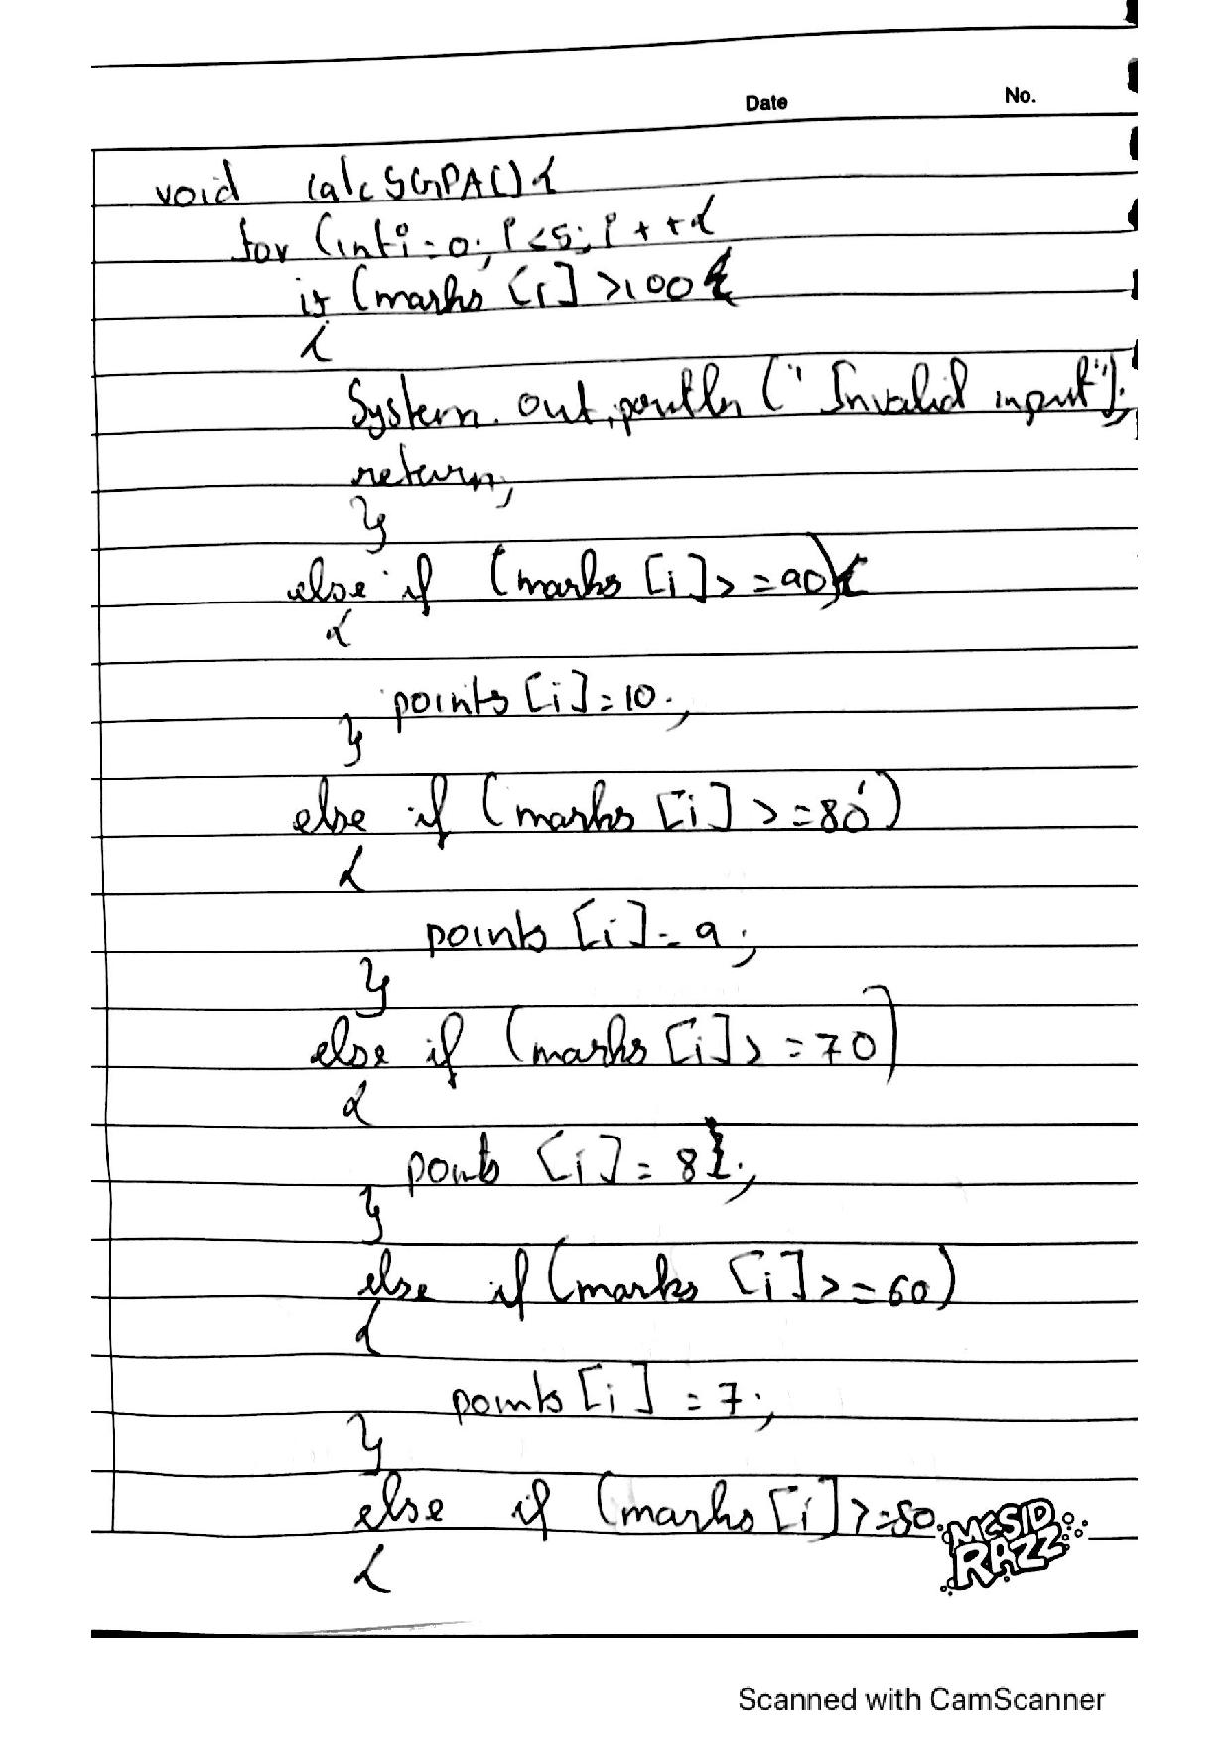

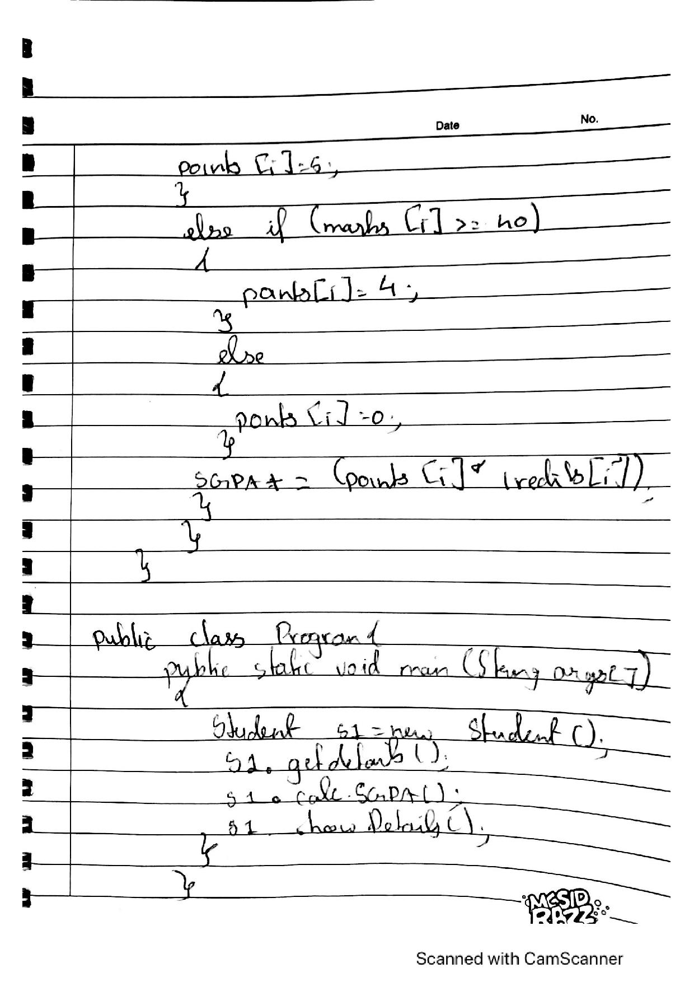

LAB 3:

import java.util.*;

import java.lang.*;

class Book {

String name, author;

double price;

int num_pages;

Scanner in = new Scanner(System.in);

Book() {

System.out.println("Enter name of book: ");

name = in.nextLine();

System.out.println("Enter name of author: ");

author = in.nextLine();

System.out.println("Enter price of book in Rs: ");

price = in.nextDouble();

System.out.println("Enter number of pages in the book: ");

num_pages = in.nextInt();

}

void show() {

System.out.println("Name: " + name);

System.out.println("Author: " + author);

System.out.println("Price: " + price);

System.out.println("Number of pages: " + num_pages);

}

public String toString() {

return name + ", By " + author + " for Rs." + price + " and has " + num_pages + " pages";

}

public static void main(String[] args) {

Scanner in = new Scanner(System.in);

int n, x;

System.out.println("Enter number of books to be created: ");

n = in.nextInt();

Book B[] = new Book[n];

for(int i = 0; i < n; i++) {

System.out.println("Book " + (i+1));

B[i] = new Book();

System.out.println();

}

for(int i = 0; i < n; i++) {

System.out.println("Book " + (i+1));

System.out.println(B[i]);

System.out.println();

}

do {

System.out.println("Enter the book number whose details you want to display: ");

x = in.nextInt();

} while(x < 1 && x > n);

B[x-1].show();

}

}

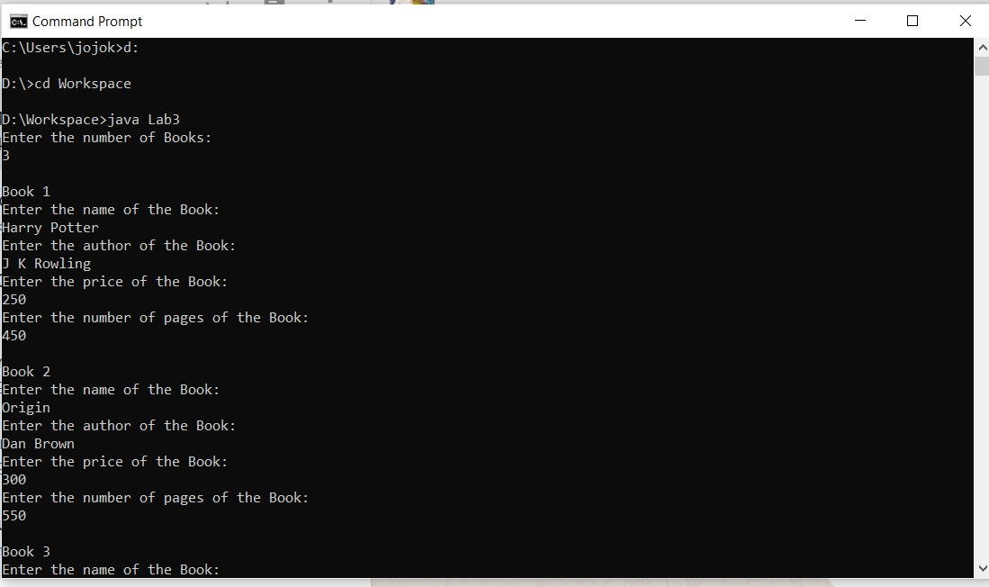

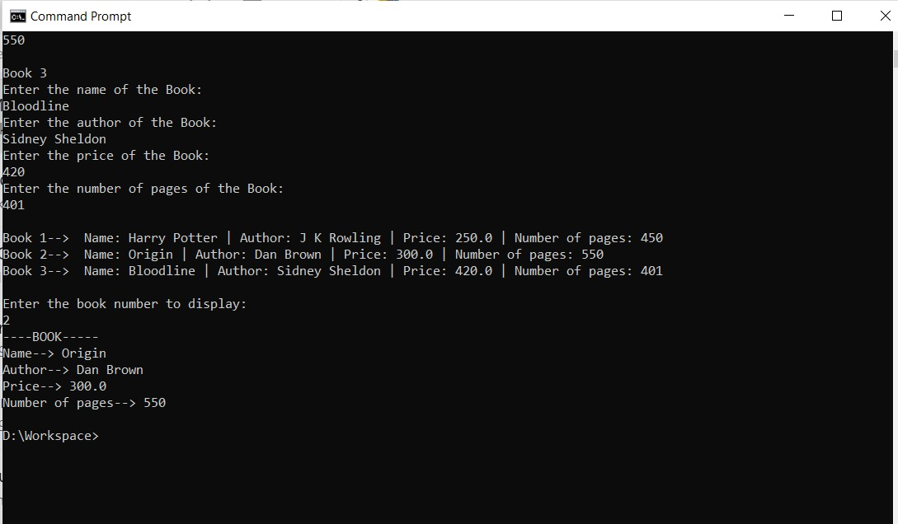

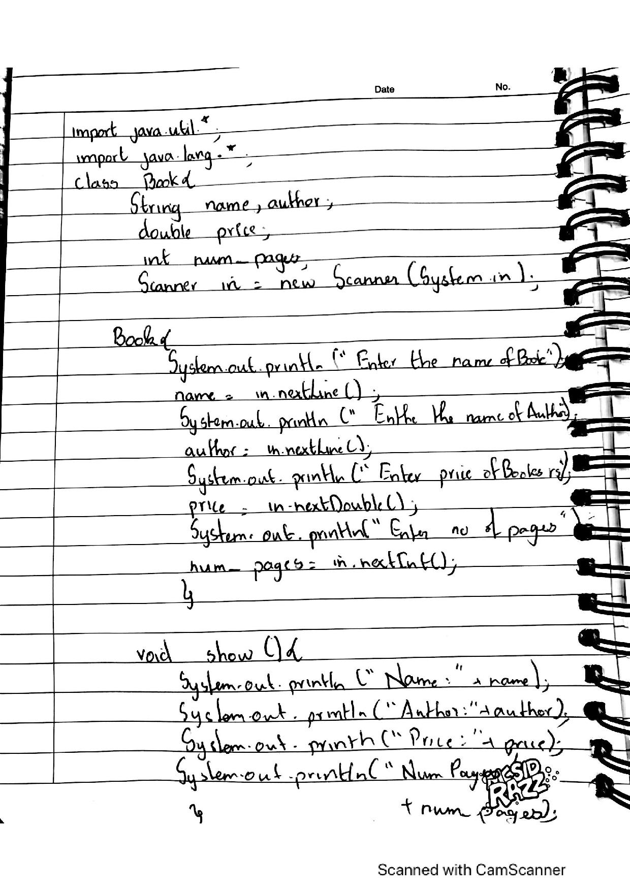

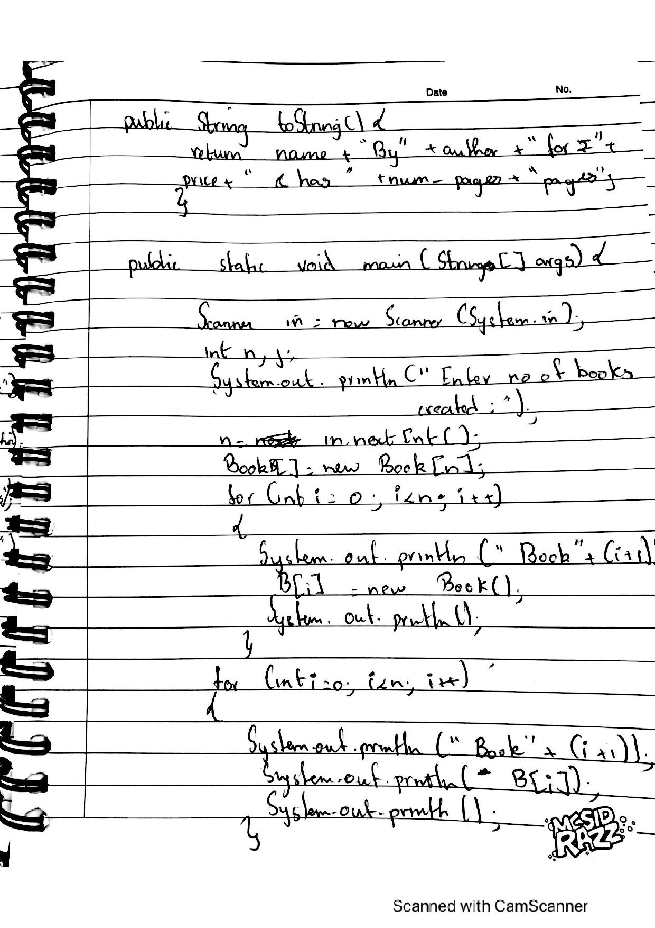

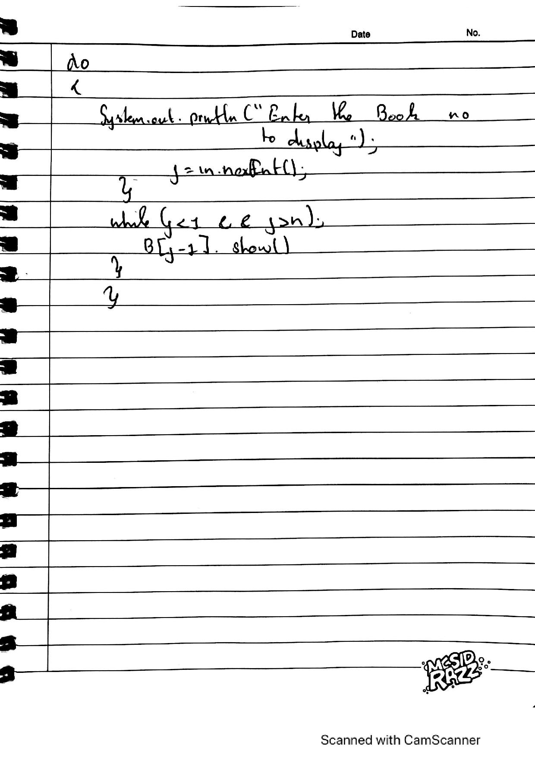

LAB 4:

import java.util.*;

import java.lang.*;

abstract class Shape{

Scanner in = new Scanner(System.in);

int x1, x2;

Shape(){

System.out.println("Enter two numbers:");

System.out.println("");

x1=in.nextInt();

x2=in.nextInt();

}

abstract void printarea();

}

class Rectangle extends Shape{

void printarea(){

System.out.println("Area of Rectangle: " + (x1 * x2));

}

}

class Triangle extends Shape{

void printarea(){

System.out.println("Area of Triangle: " + (x1 * x2)/2);

}

}

class Circle extends Shape{

void printarea(){

System.out.println("Area of Circle 1: " + (3.14 * x1 * x1));

System.out.println("Area of Circle 2: " + (3.14 * x2 * x2));

}

}

class Abstract{

public static void main(String[]args){

Shape s;

s = new Rectangle();

s.printarea();

s = new Triangle();

s.printarea();

s = new Circle();

s.printarea();

}

}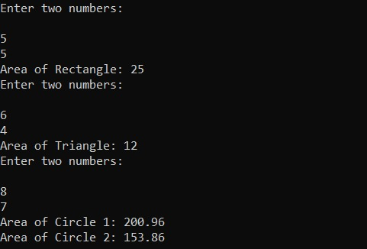

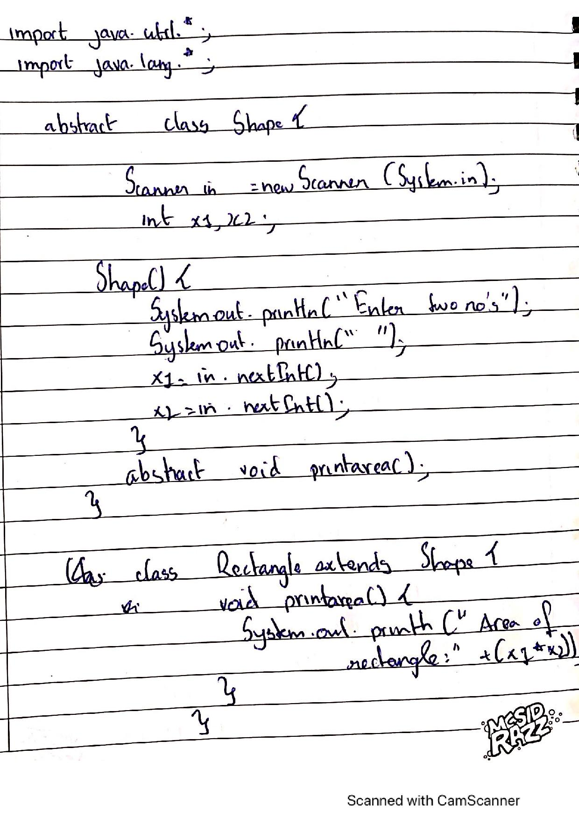

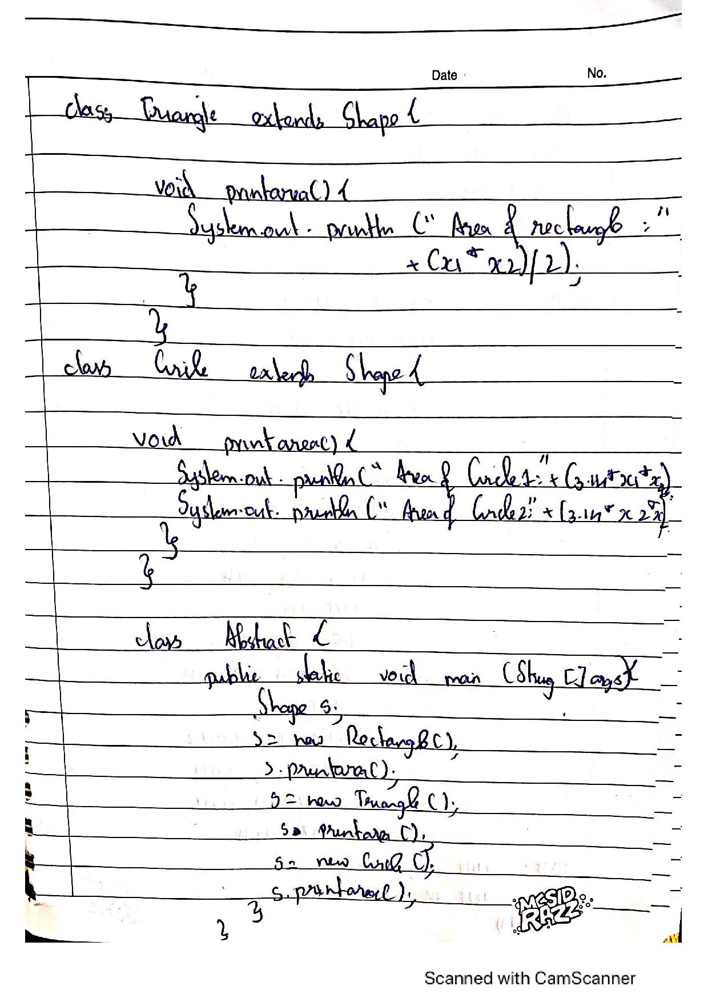

LAB 5:

import java.util.*;

import java.lang.*;

class Account {

String name, abc;

int accNo;

char accType;

double bal = 0;

double deposit;

Scanner in = new Scanner(System.in);

void input_data() {

System.out.println("Enter your account type (S/C):");

abc = in.nextLine();

accType = abc.charAt(0);

}

void deposit() {

System.out.println("Enter an amount to deposit: ");

deposit = in.nextDouble();

bal += deposit;

System.out.println("Balance has been updated. ");

}

void view_balance() {

System.out.println("Balance = " + bal);

}

public static void main(String[] args) {

Scanner s = new Scanner(System.in);

int x;

Account a1 = new Account();

a1.input_data();

if(a1.accType == 'C' || a1.accType == 'c'){

Current a2 = new Current();

do {

System.out.println("WELCOME TO YOUR CURRENT ACCOUNT");

System.out.println("1. Deposit ");

System.out.println("2. Check Balance ");

System.out.println("3. Issue Cheque ");

System.out.println("4. Exit");

System.out.println("Enter your choice: ");

x = s.nextInt();

switch(x) {

case 1: a2.deposit();

break;

case 2: a2.check_balance();

break;

case 3: a2.issue_cheque();

break;

case 4: System.exit(0);

break;

default: System.out.println("ERROR. INVALID CHOICE.");

}

} while(x <= 4 && x >= 1);

}

else if (a1.accType == 'S' || a1.accType == 's'){

Savings a3 = new Savings();

do {

System.out.println("WELCOME TO YOUR SAVINGS ACCOUNT");

System.out.println("1. Deposit");

System.out.println("2. View Balance");

System.out.println("3. Withdraw ");

System.out.println("4. Calculate compound interest ");

System.out.println("5. Exit ");

System.out.println("Enter your choice: ");

x = s.nextInt();

switch(x) {

case 1: a3.deposit();

break;

case 2: a3.view_balance();

break;

case 3: a3.withdraw_balance();

break;

case 4: a3.compute_CI();

break;

case 5: System.exit(0);

break;

default: System.out.println("ERROR. INVALID CHOICE.");

}

} while(x <= 5 && x >=1);

}

else System.out.println("INVALID ACCOUNT TYPE");

}

}

class Current extends Account {

Current() {

System.out.println("Enter your name: ");

name = in.nextLine();

System.out.println("Enter your account number: ");

accNo = in.nextInt();

deposit();

}

double chq_amount;

void issue_cheque() {

System.out.println("Enter amount for which cheque is to be issued.");

chq_amount = in.nextDouble();

if(chq_amount > bal) {

System.out.println("ERROR! Insufficient balance in account.");

}

else {

bal -= chq_amount;

System.out.println("Cheque has been issued SUCCESSFULLY");

}

}

void check_balance() {

if(bal < 1000) {

System.out.println("Current available balance is lesser than minimum required balance.");

bal -= 100;

System.out.println("Service charge of Rs.100 has been deducted from your balance.");

}

view_balance();

}

}

class Savings extends Account {

double CI, withdrawal_ammount, time;

Savings() {

System.out.println("Enter your name: ");

name = in.nextLine();

System.out.println("Enter your account number: ");

accNo = in.nextInt();

deposit();

}

void compute_CI() {

System.out.println("Enter time period: ");

time = in.nextInt();

CI = bal * Math.pow(1 + (0.08 / 12), 12 * time) - bal;

System.out.println("CI = " + CI);

bal += CI;

System.out.println("CI has been deposited");

}

void withdraw_balance() {

System.out.println("Enter the amount you want to withdraw: ");

withdrawal_ammount = in.nextDouble();

if(withdrawal_ammount > bal) {

System.out.println("ERROR! THE ENTERED AMOUNT IS GREATER THAN THE AVAILABLE BALANCE...");

}

else {

bal -= withdrawal_ammount;

System.out.println("AMOUNT HAS SUCCESSFULLY BEEN WITHDRAWN!");

}

}

}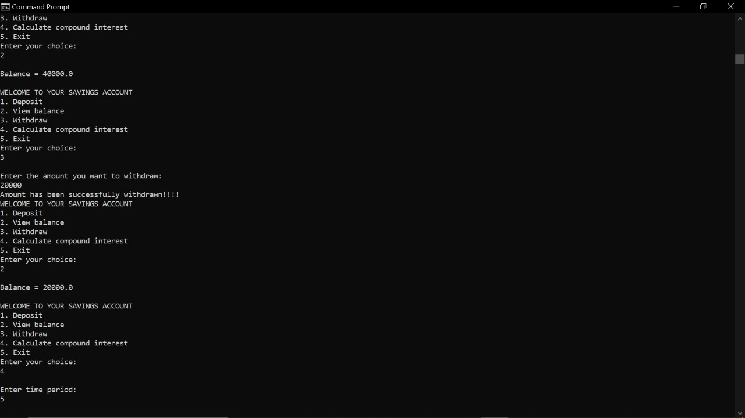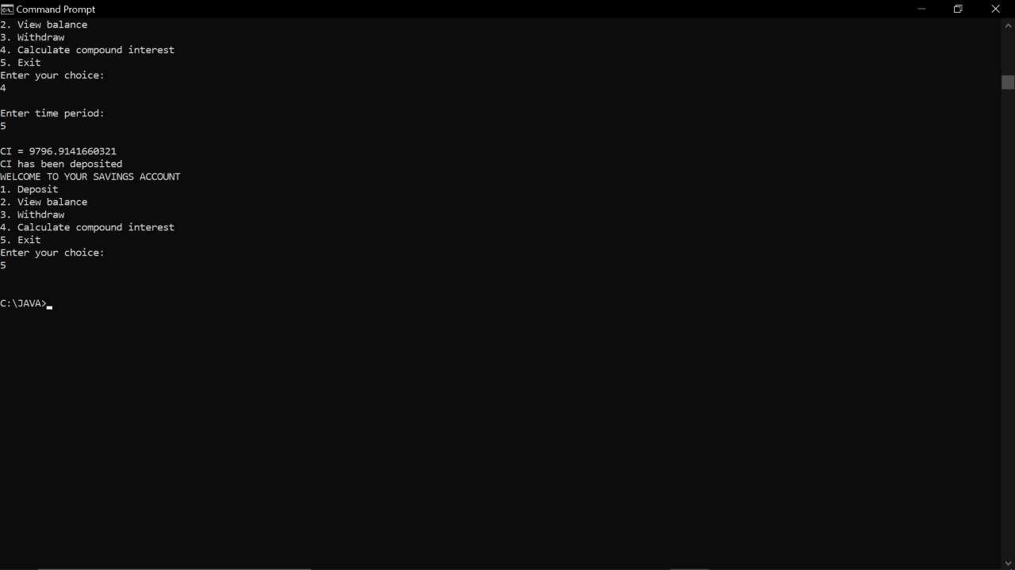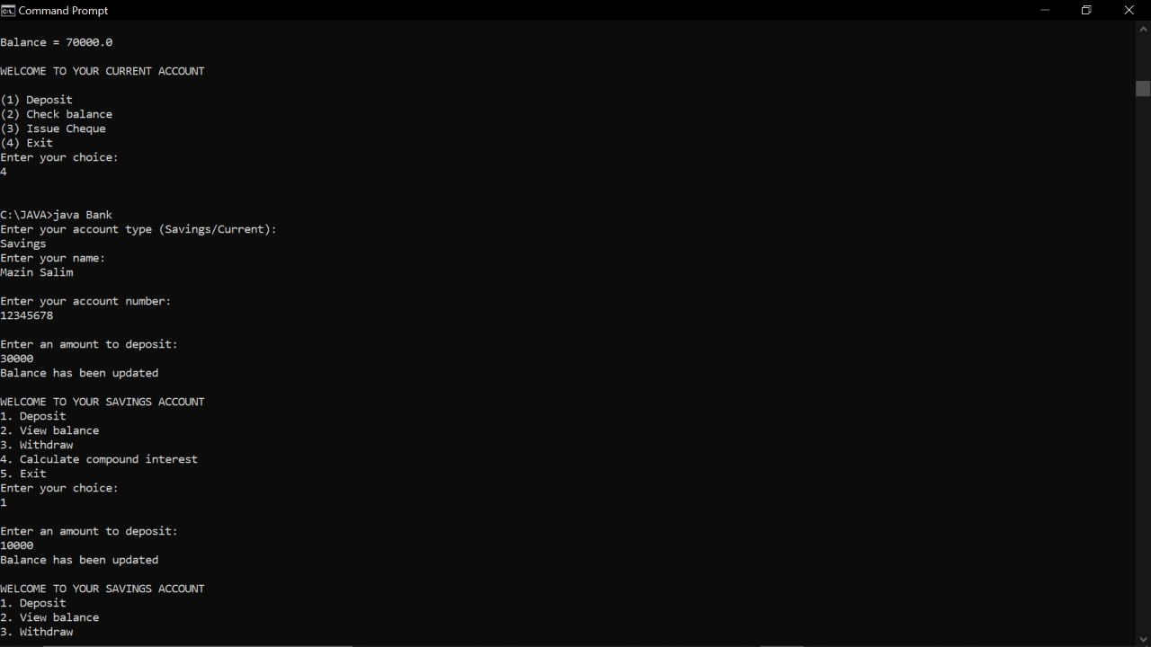

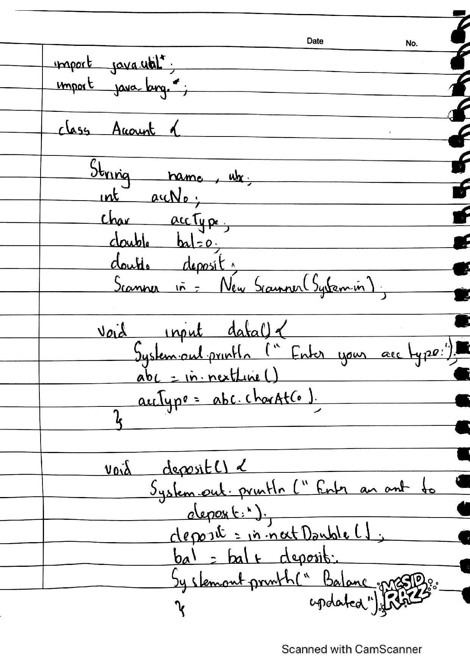

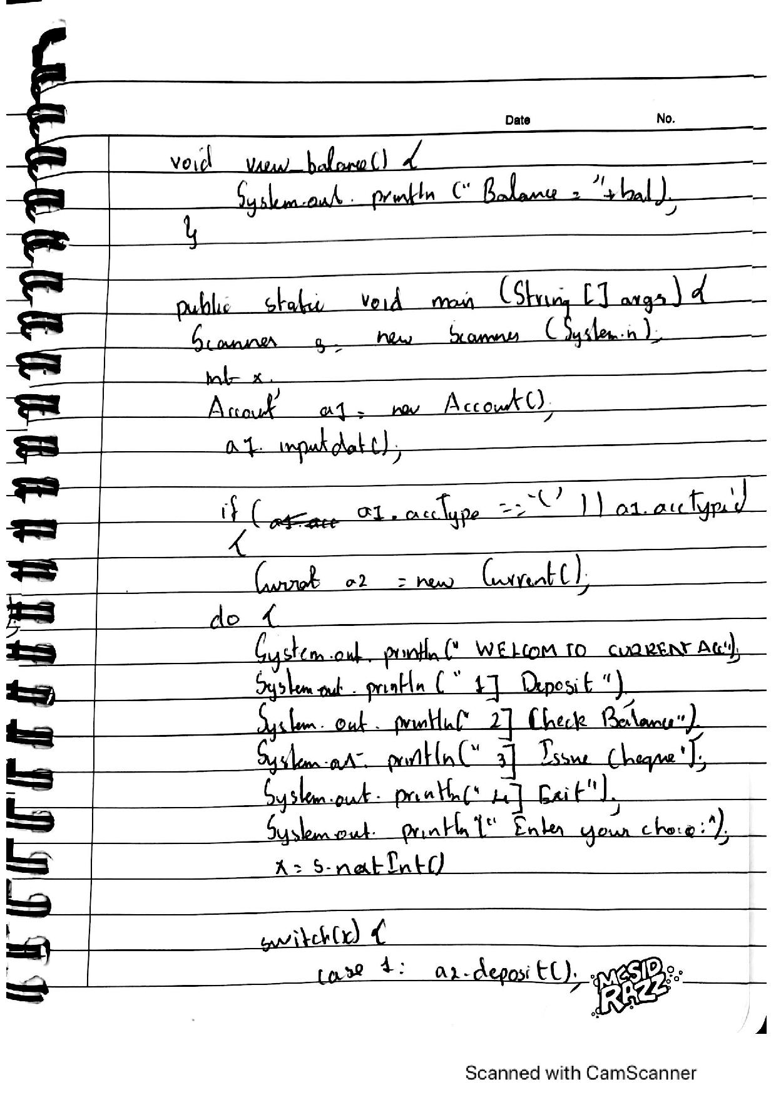

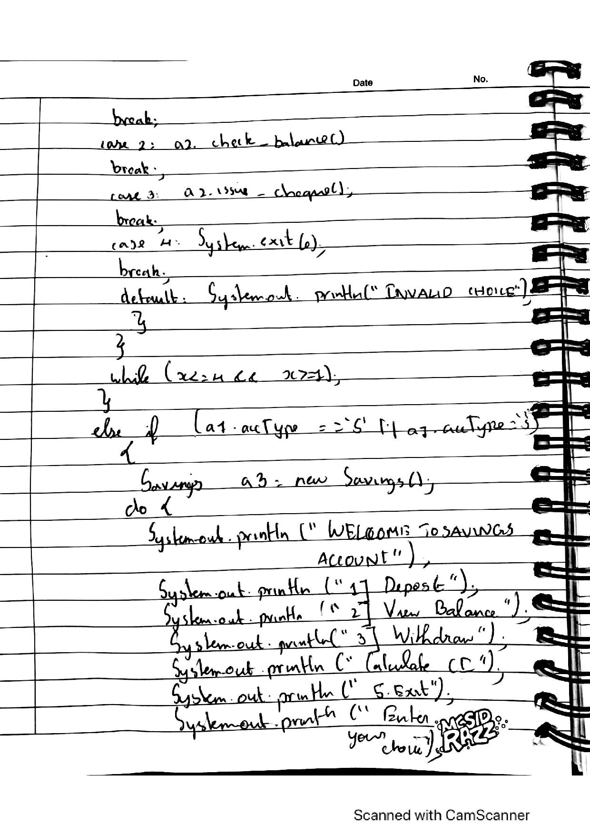

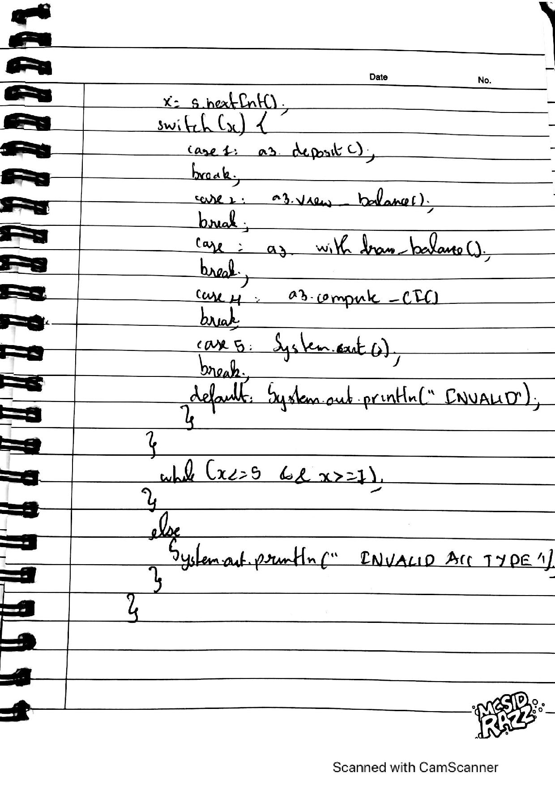

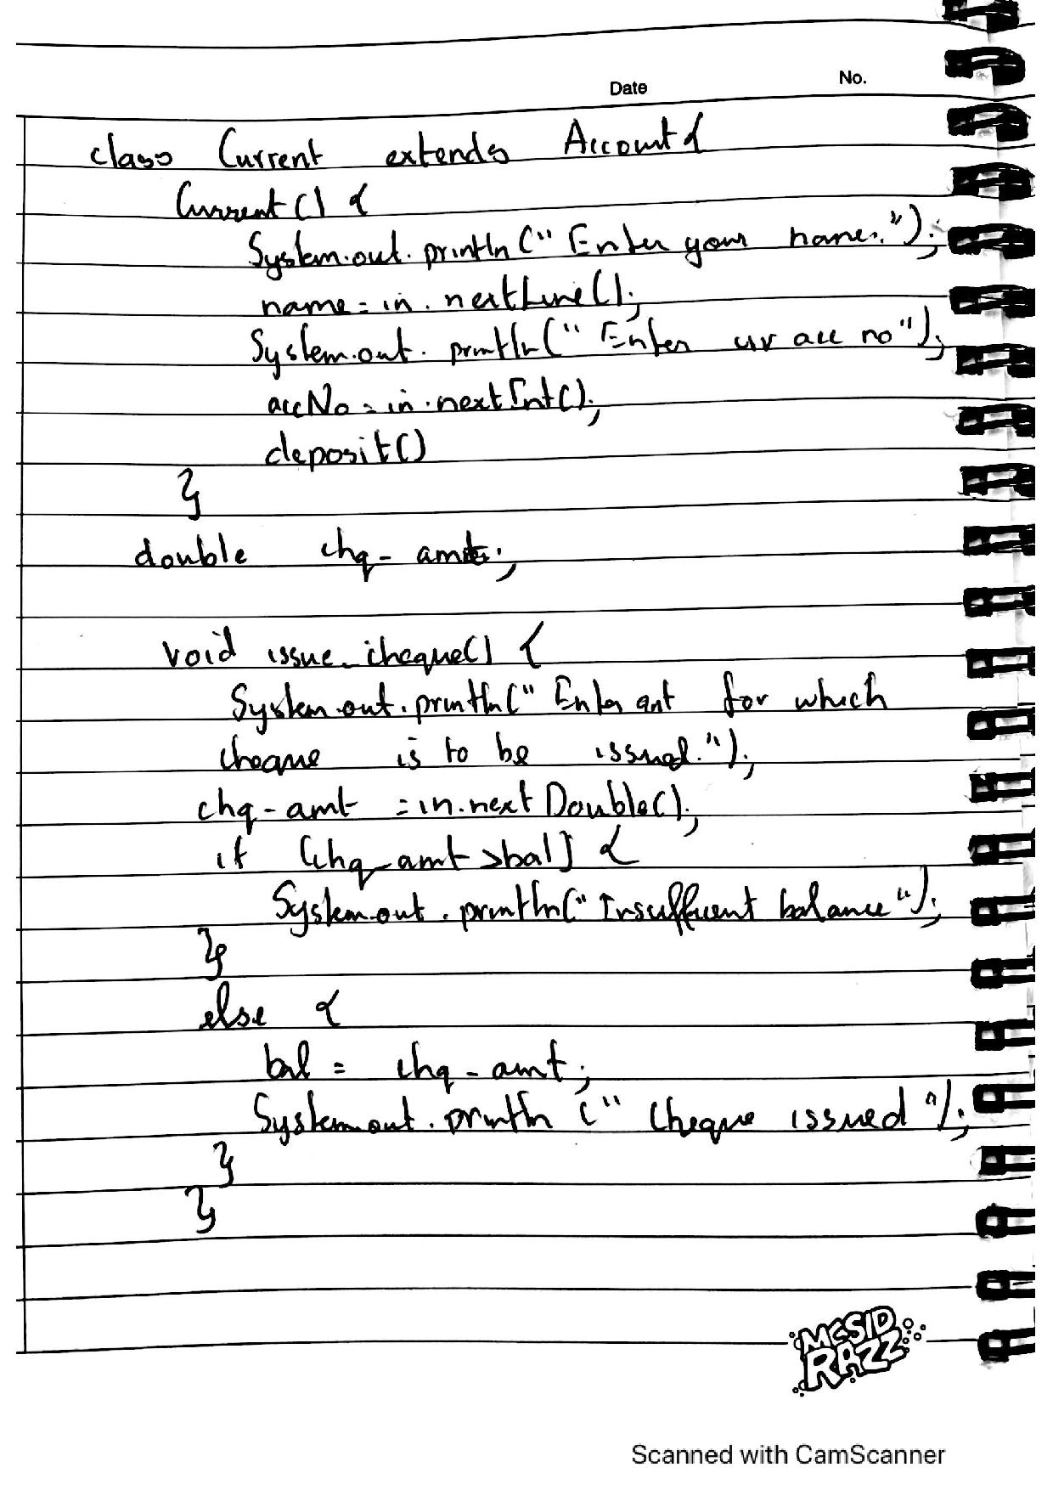

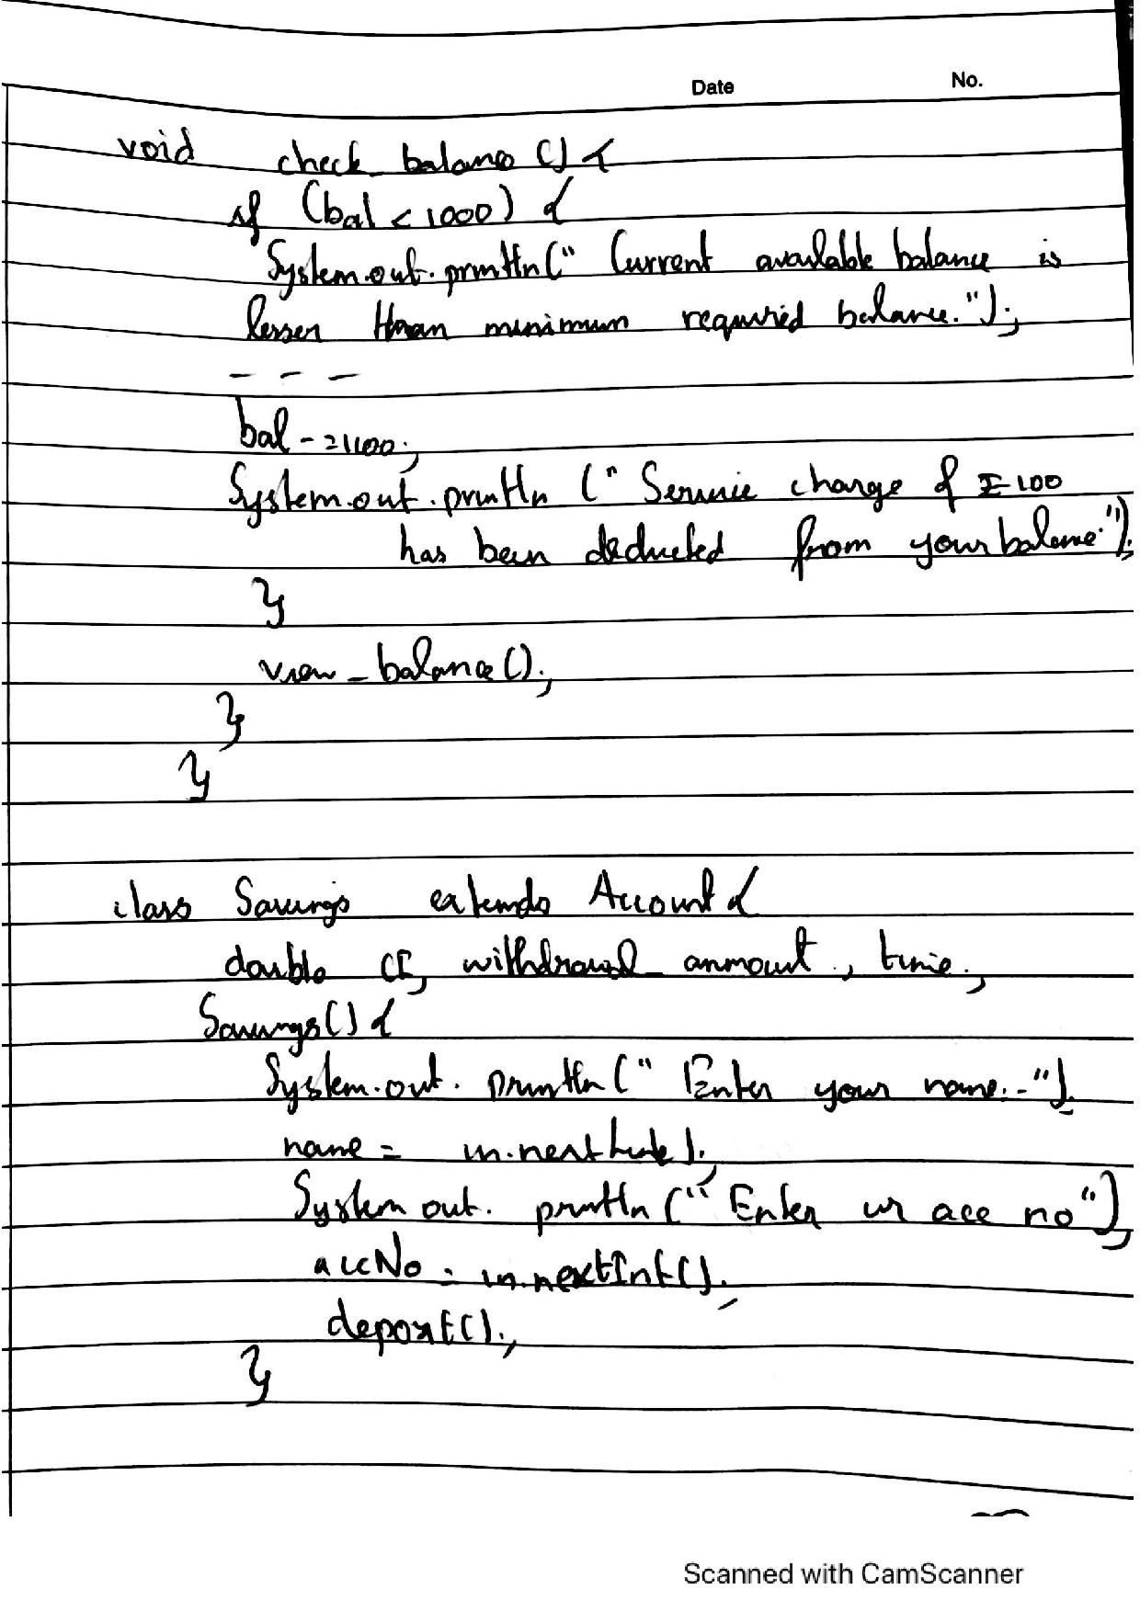

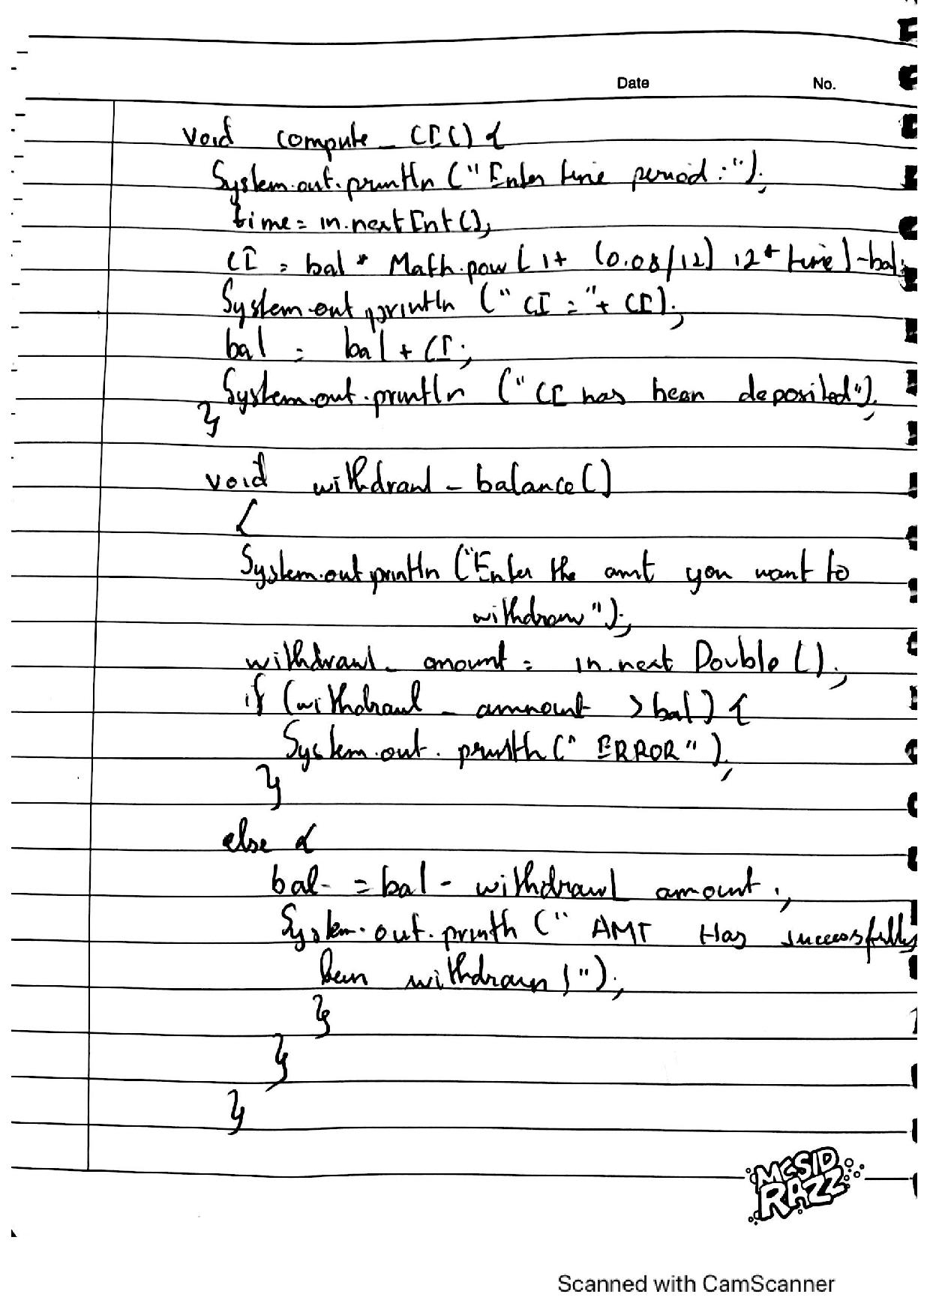

LAB 6

import CIE.*;

import SEE.*;

import java.util.*;

class Main

{

public static void main(String args[])

{

Scanner sx = new Scanner(System.in);

System.out.println("Enter the number of students");

int n= sx.nextInt();

CIE.internals in[]= new CIE.internals[n];

SEE.externals en[]= new SEE.externals[n];

int i,j;

for(i=0;i<n;i++)

{

System.out.println("Student "+(i+1));

in[i] = new CIE.internals();

en[i] = new SEE.externals();

in[i].read();

System.out.println("CIE MARKS:");

in[i].accept();

System.out.println("SEE MARKS:");

en[i].get();

System.out.println();

in[i].display();

for(j=0;j<5;j++)

System.out.println("Total Marks for course "+(j+1)+": "+(in[i].cie[j] + (en[i].see[j]/2)));

}

}

}

package SEE;

import java.util.*;

import CIE.*;

public class externals extends personal

{

public double see[];

public void get()

{

see= new double[5];

Scanner sc = new Scanner(System.in);

for(int i=0;i<5;i++)

{

System.out.println("SEE mark for course "+(i+1)+" : ");

see[i]= sc.nextDouble();

}

}

}

package CIE;

import java.util.*;

public class personal

{

public String name;

public int sem;

public String usn;

public void read()

{

Scanner sc = new Scanner(System.in);

System.out.println("Enter the name");

name = sc.next();

System.out.println("Enter the semester");

sem = sc.nextInt();

System.out.println("Enter the USN");

usn = sc.next();

}

public void display()

{

System.out.println("Student details: ");

System.out.println("Name: "+name+"\nUSN: "+usn+"\nSem: "+sem);

}

}

package CIE;

import java.util.*;

public class internals extends personal

{

public double cie[];

public void accept()

{

cie= new double[5];

Scanner sc = new Scanner(System.in);

for(int i=0;i<5;i++)

{

System.out.println("CIE mark for course "+(i+1)+" : ");

cie[i]= sc.nextDouble();

}

}

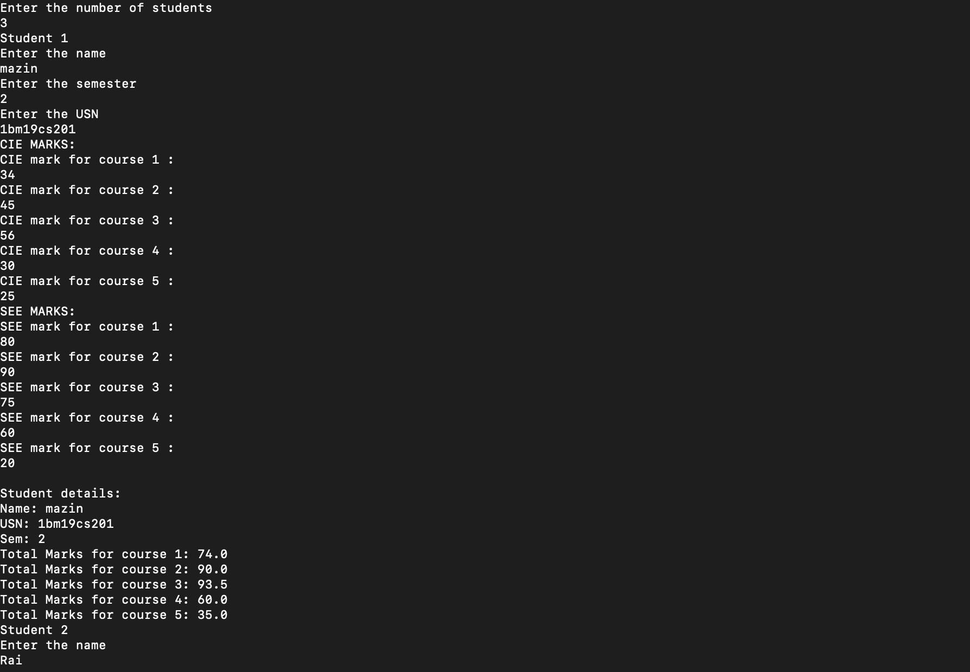

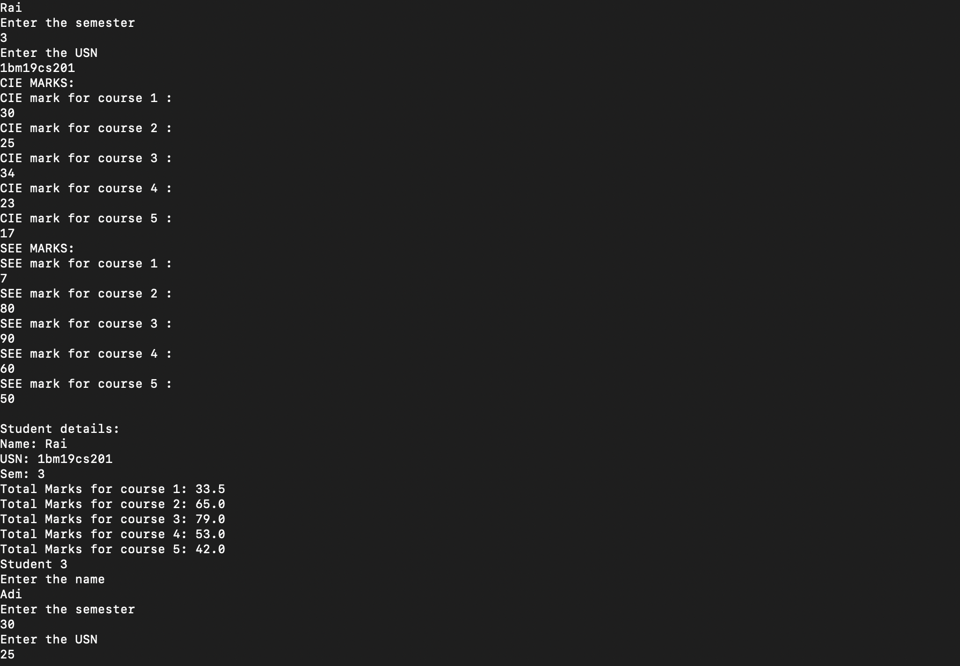

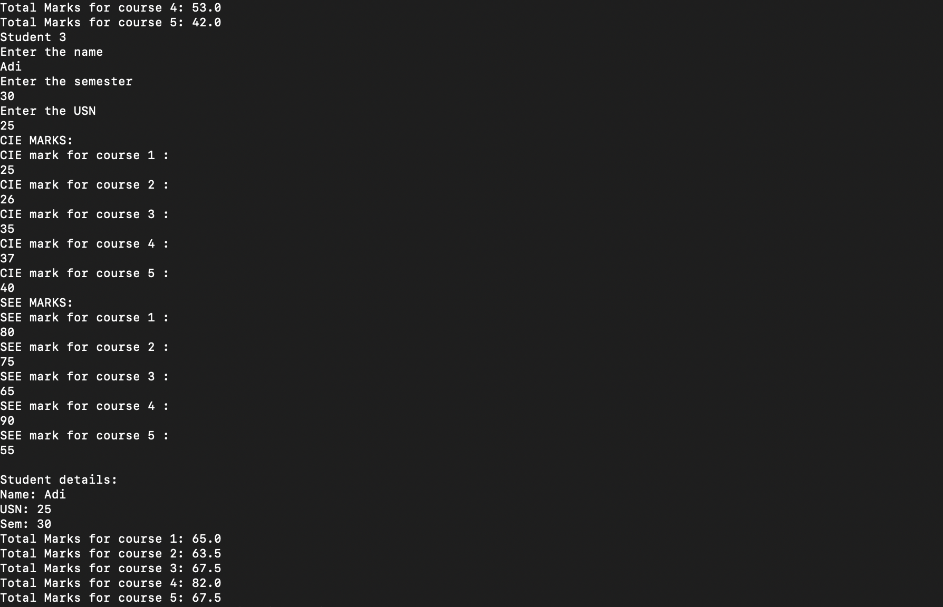  
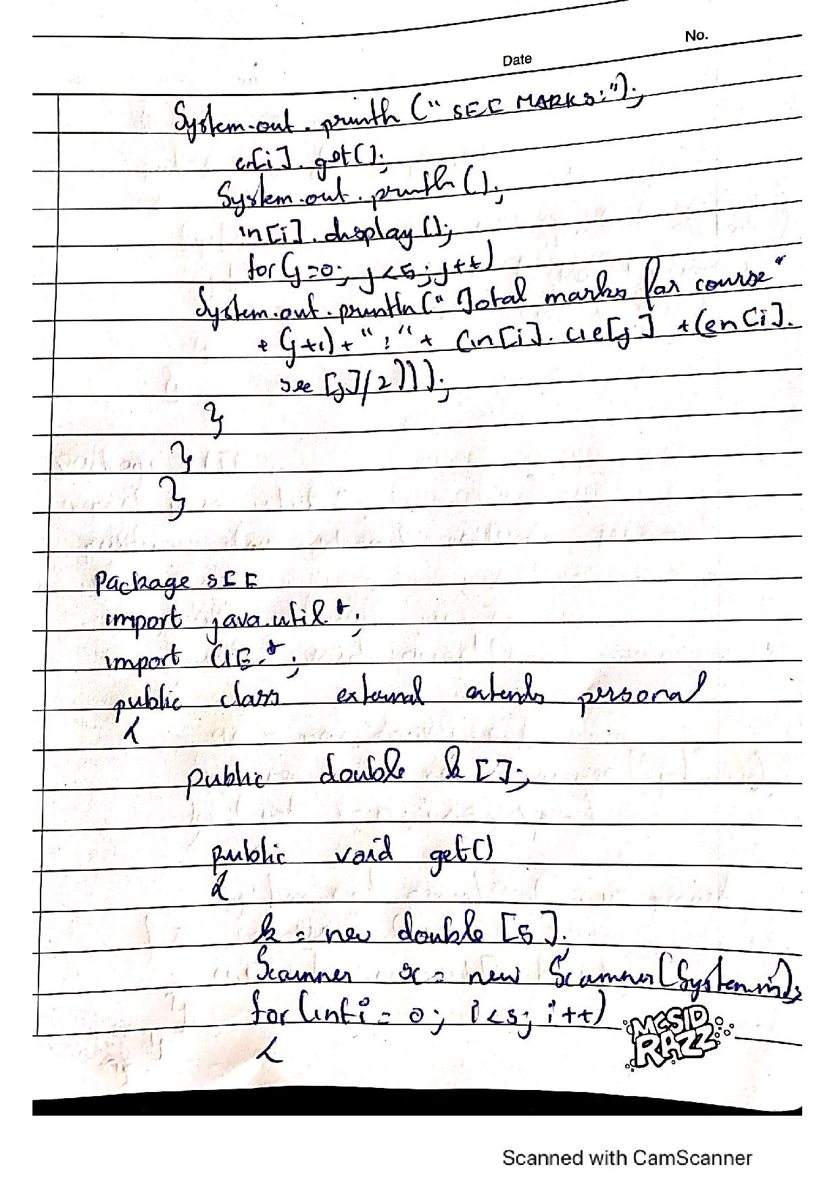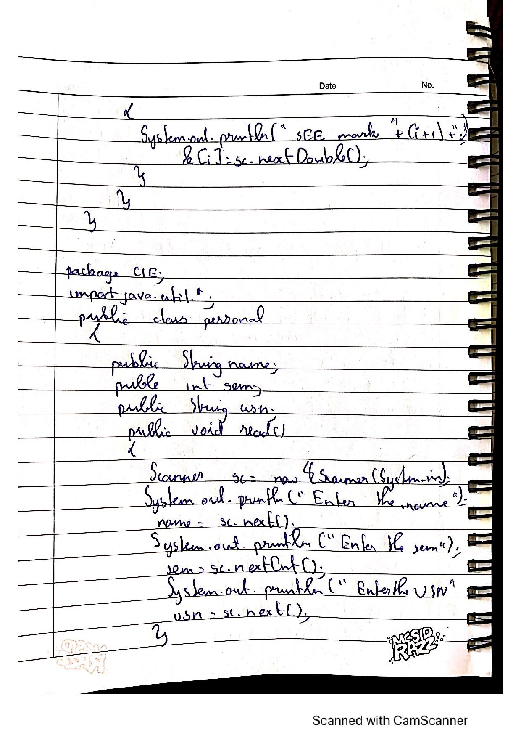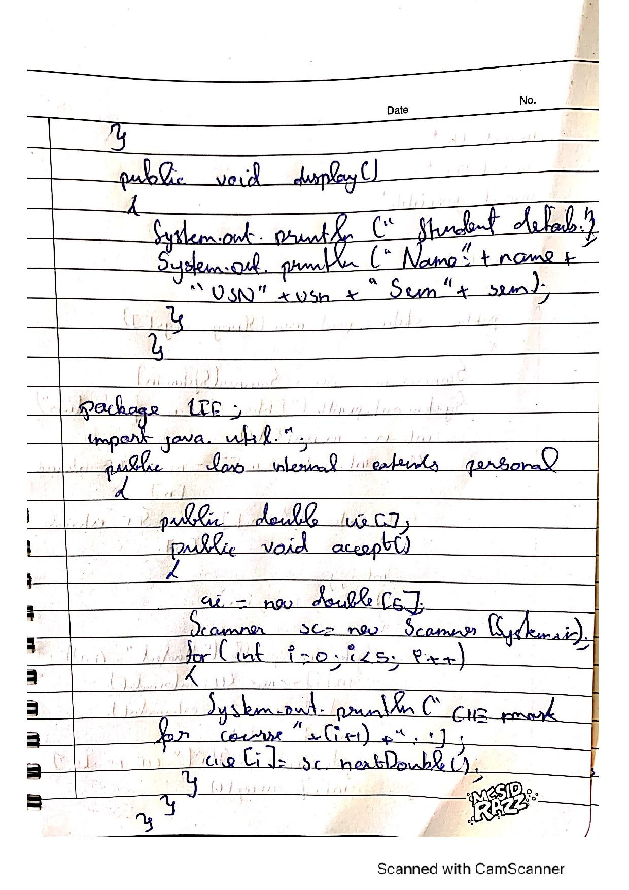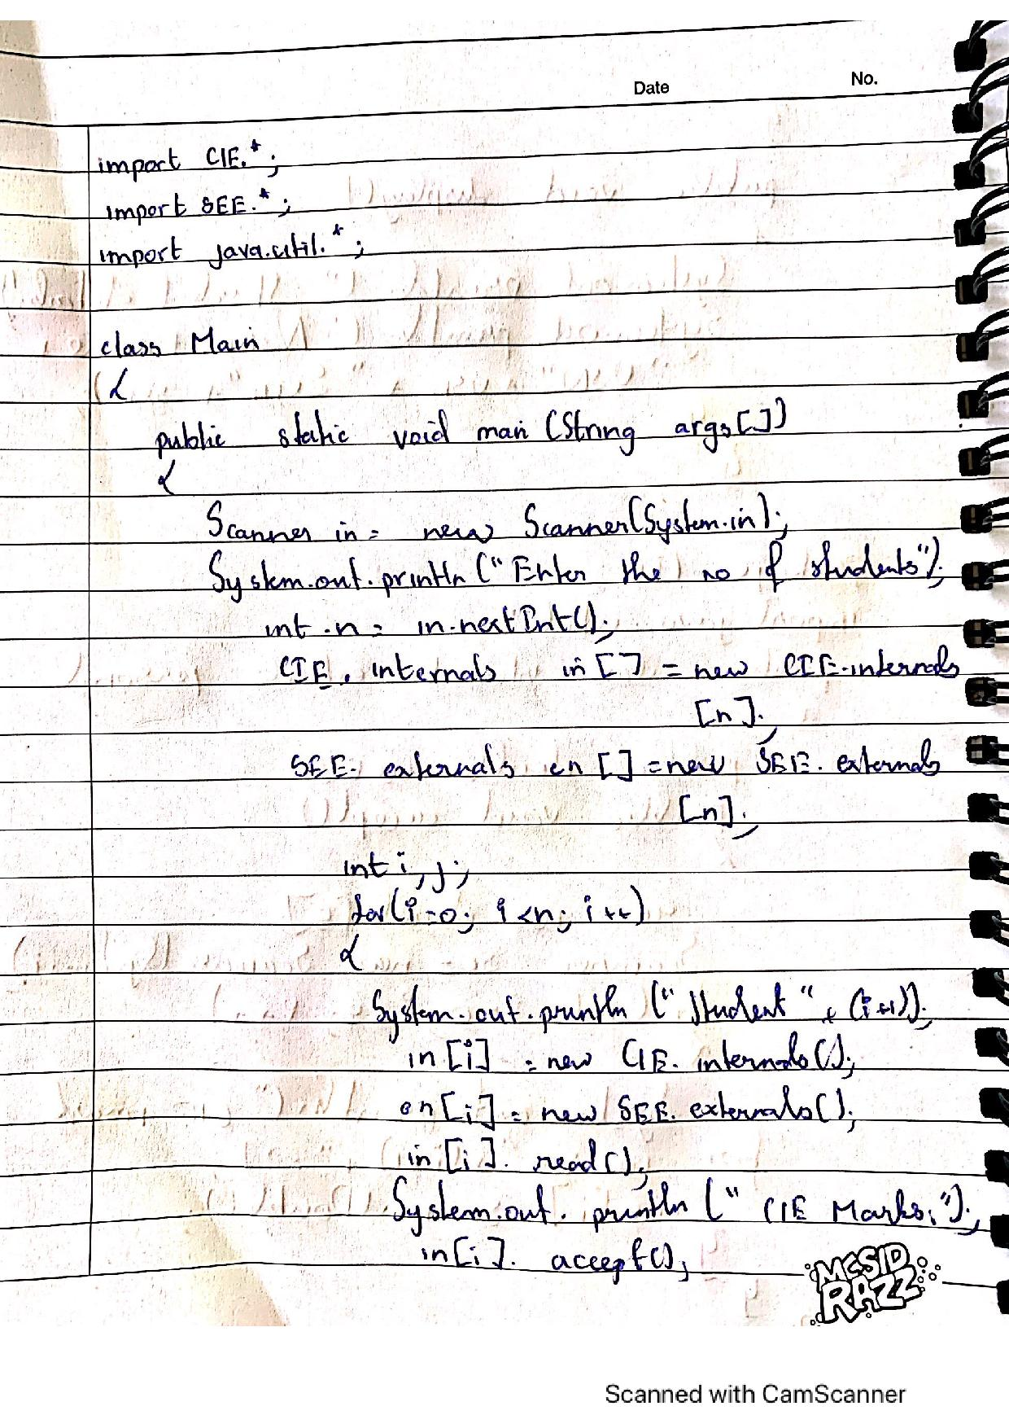

LAB -7

import java.util.*;

import java.lang.*;

class Generics<X,Y,Z>{

X ob1;

Y ob2;

Z ob3;

Generics(X x,Y y,Z z){

ob1 = x;

ob2 = y;

ob3 = z;

}

void showTypes(){

System.out.println("Type of X is "+ob1.getClass().getName());

System.out.println("Type of Y is "+ob2.getClass().getName());

System.out.println("Type of Z is "+ob3.getClass().getName());

}

X getob1(){

return ob1;

}

Y getob2(){

return ob2;

}

Z getob3(){

return ob3;

}

}

class LAB7{

public static void main(String args[]){

Generics<Integer,Double,String> A = new Generics<Integer,Double,String>(22,150067.09,"Test");

A.showTypes();

int i = A.getob1();

System.out.println("Value:"+i);

double g= A.getob2();

System.out.println("Value:"+g);

String str = A.getob3();

System.out.println("Value:"+str);

}

}

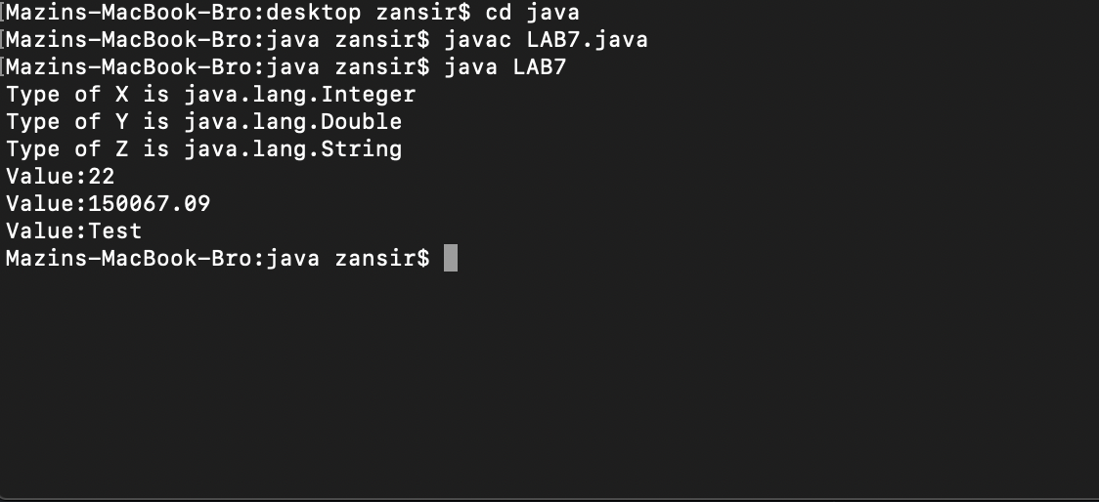

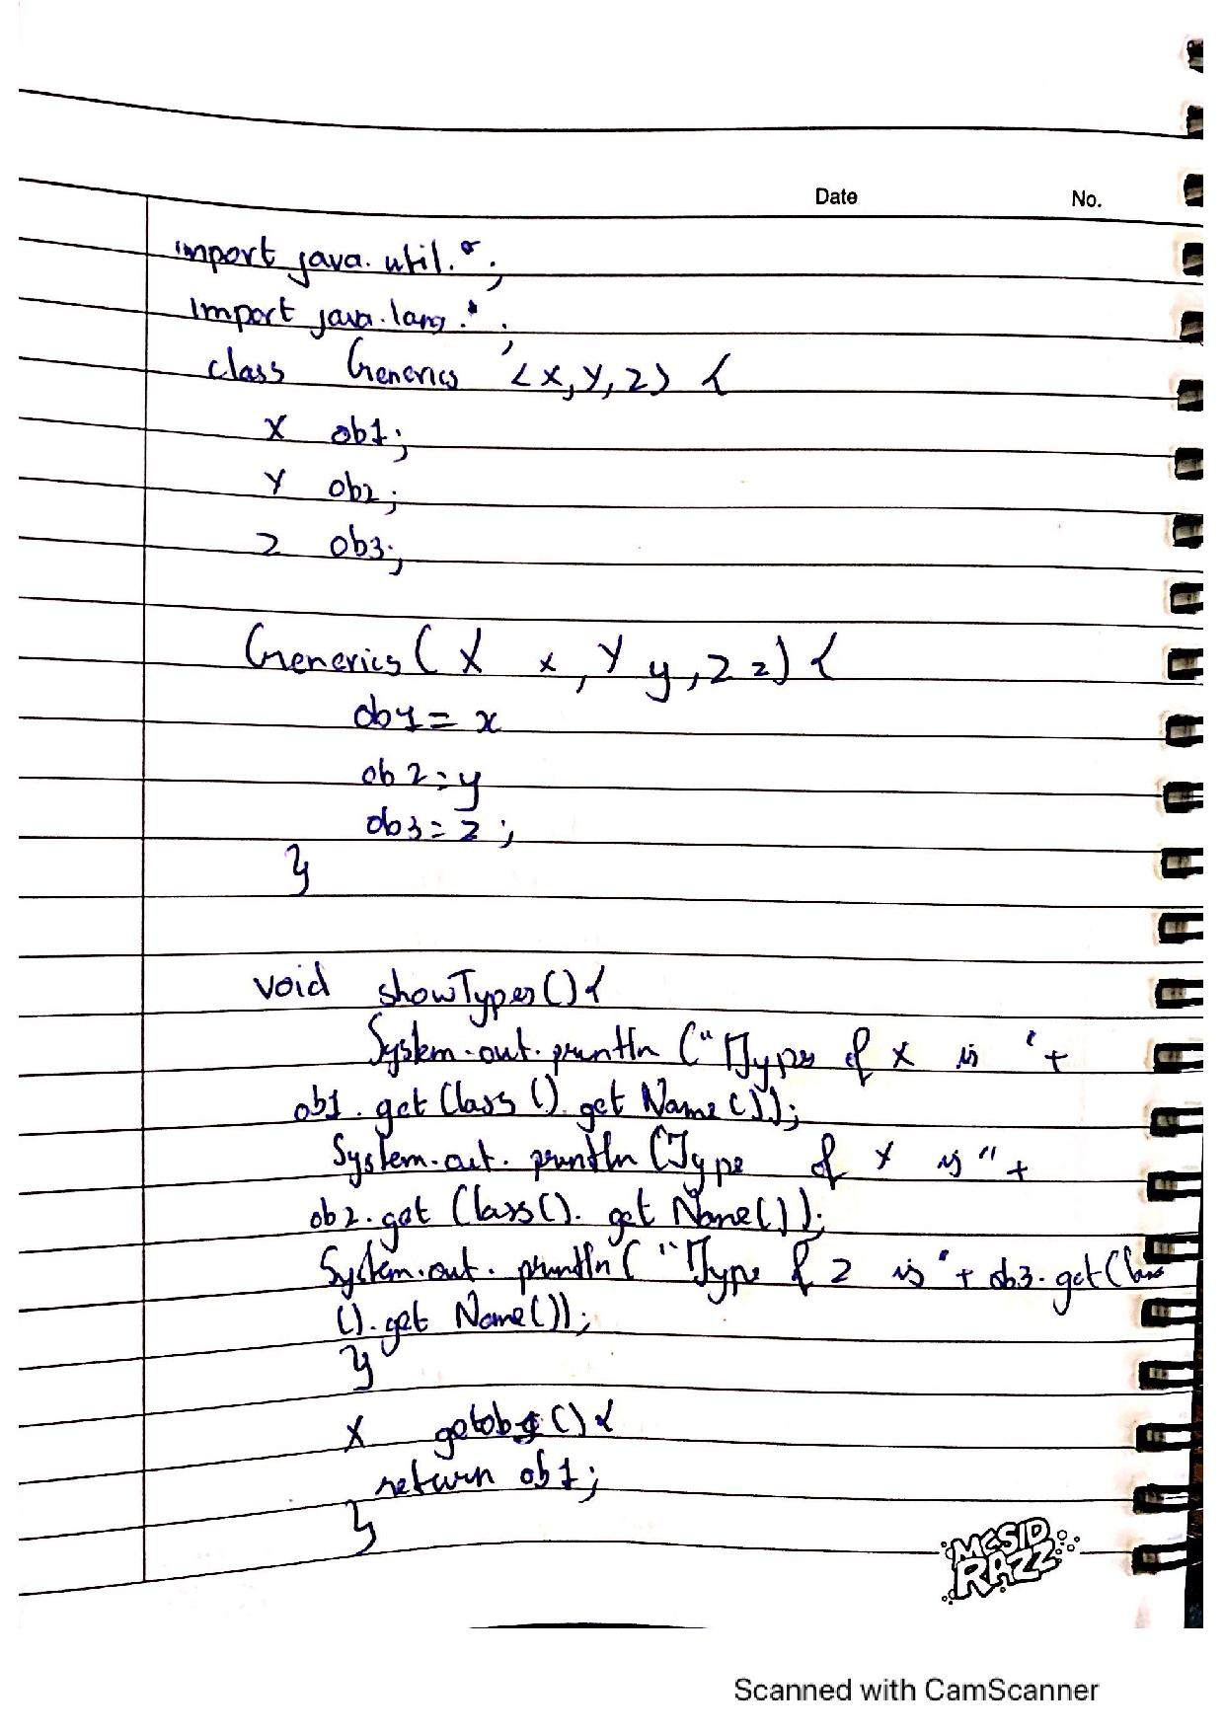

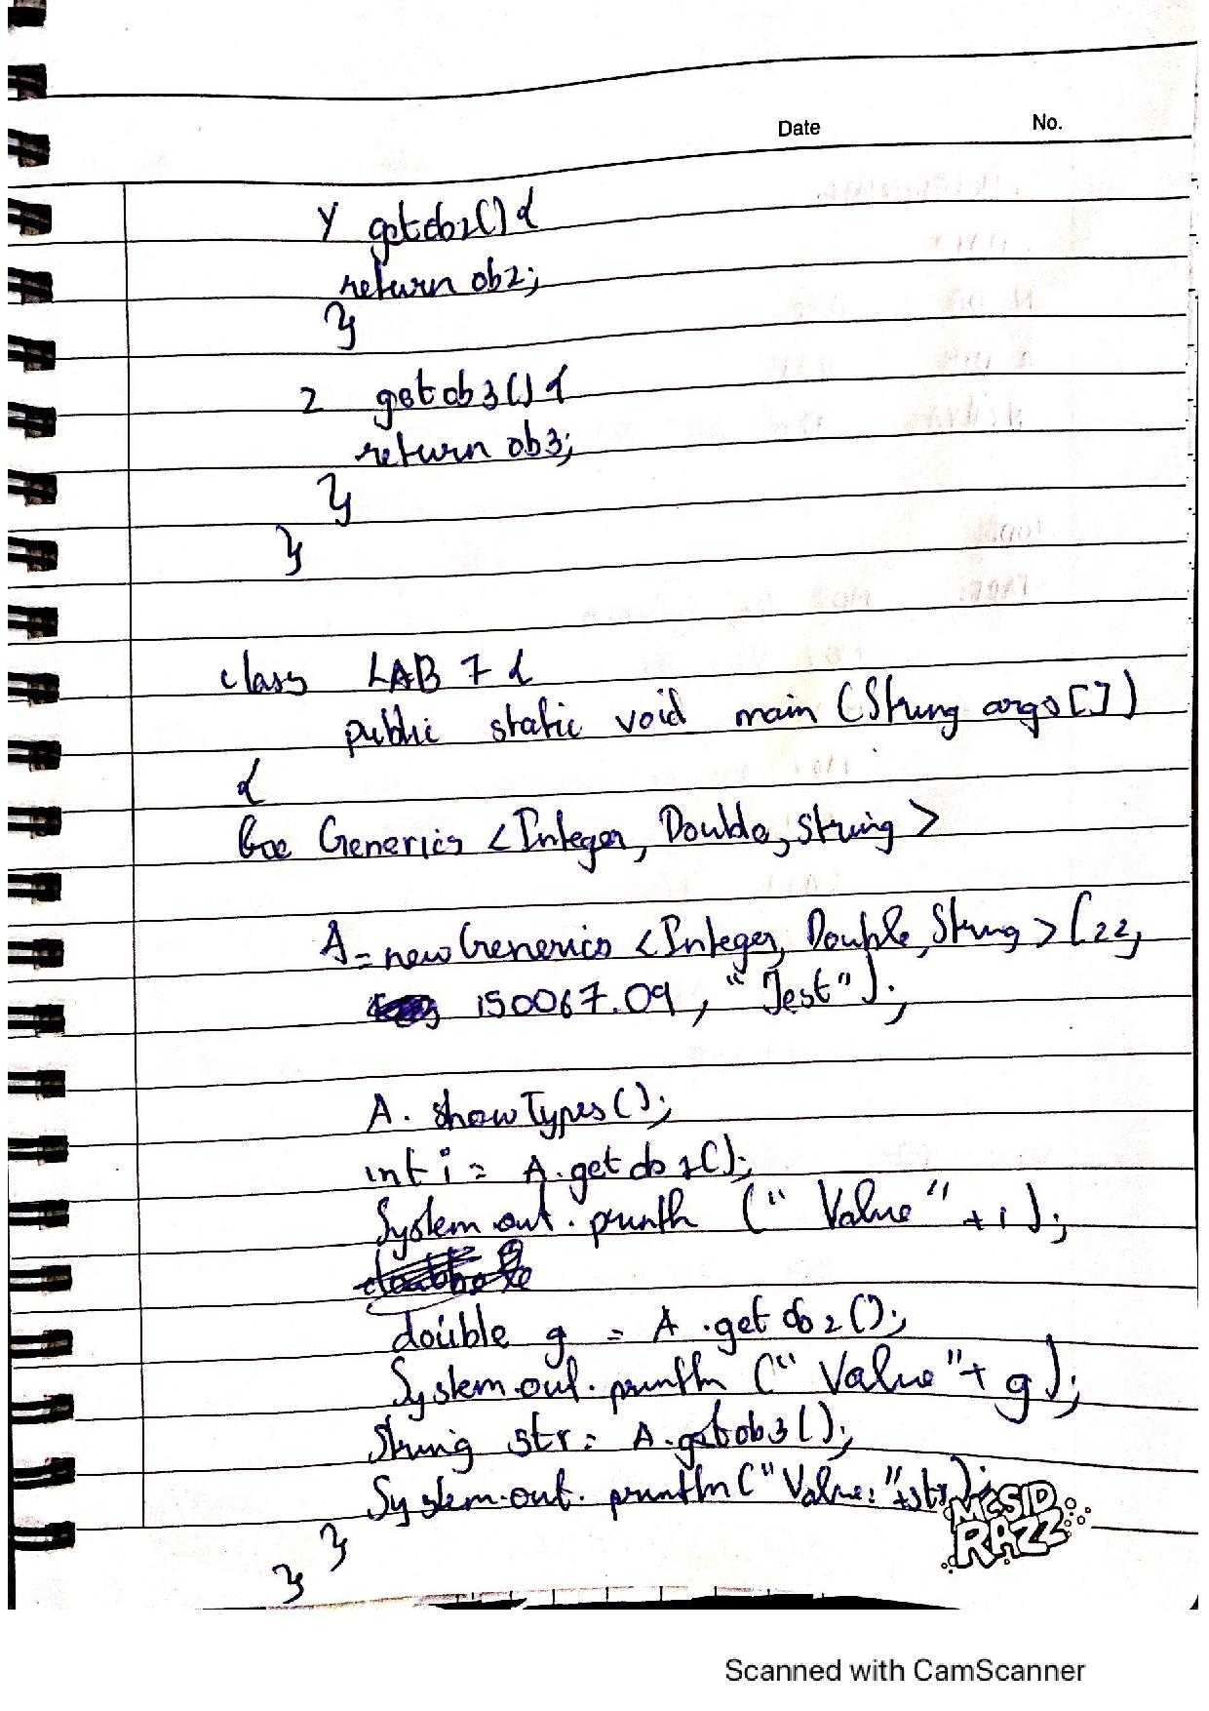

LAB -8

import java.util.Scanner;

class fatherAgeException extends Exception

{

public String toString()

{

return("Wrong Age!! Father's age is less than 0");

}

}

class sonAgeException extends Exception

{

int a, b;

sonAgeException (int sage, int fage)

{

a = sage;

b = fage;

}

public String toString()

{

if(a==b)

return("Wrong Age!! Son's age is equal to father's age");

/* if(a<0)

return("Wrong Age!! Son's age is less than 0");

*/ else

return("Wrong Age!! Son's age is more than father's age");

}

}

class Father

{

public int agel;

Scanner scan = new Scanner(System.in);

int age1;

Father()

{

System.out.print("Enter father's age: ");

age1 = scan.nextInt();

}

void ex1() throws fatherAgeException

{

if (age1 < 0)

throw new fatherAgeException();

}

}

class Son extends Father

{

public int age2;

Son()

{

System.out.print("Enter son's age: ");

age2 = scan.nextInt();

}

void ex2() throws sonAgeException

{

if(age2 < 0 || age2>=age1)

throw new sonAgeException (age2, age1);

}

}

class age

{

public static void main(String [] args){

Son s = new Son();{

try{

s.ex1();

}

catch(fatherAgeException e)

{

System.out.println(e);

}

try

{

s.ex2();

}

catch (sonAgeException e)

{

System.out.println(e);

}

}

}

}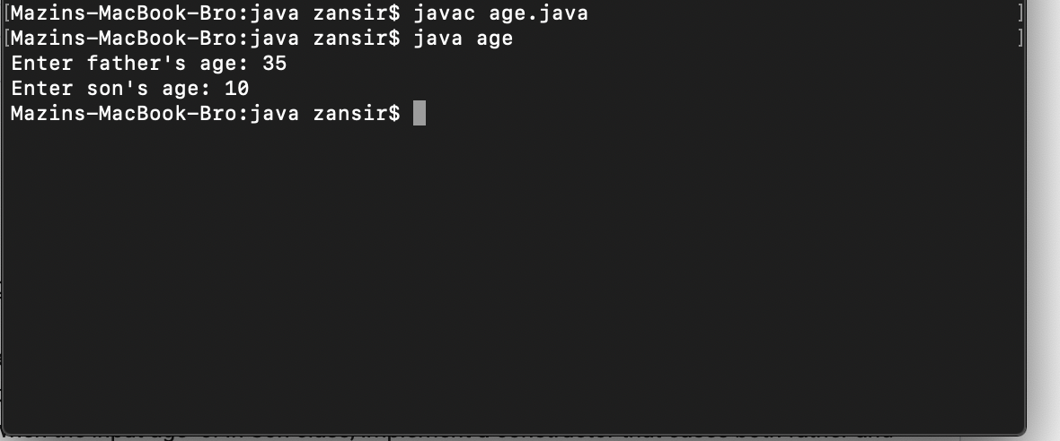

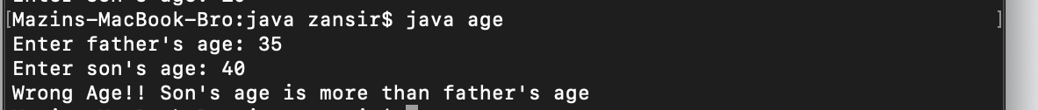

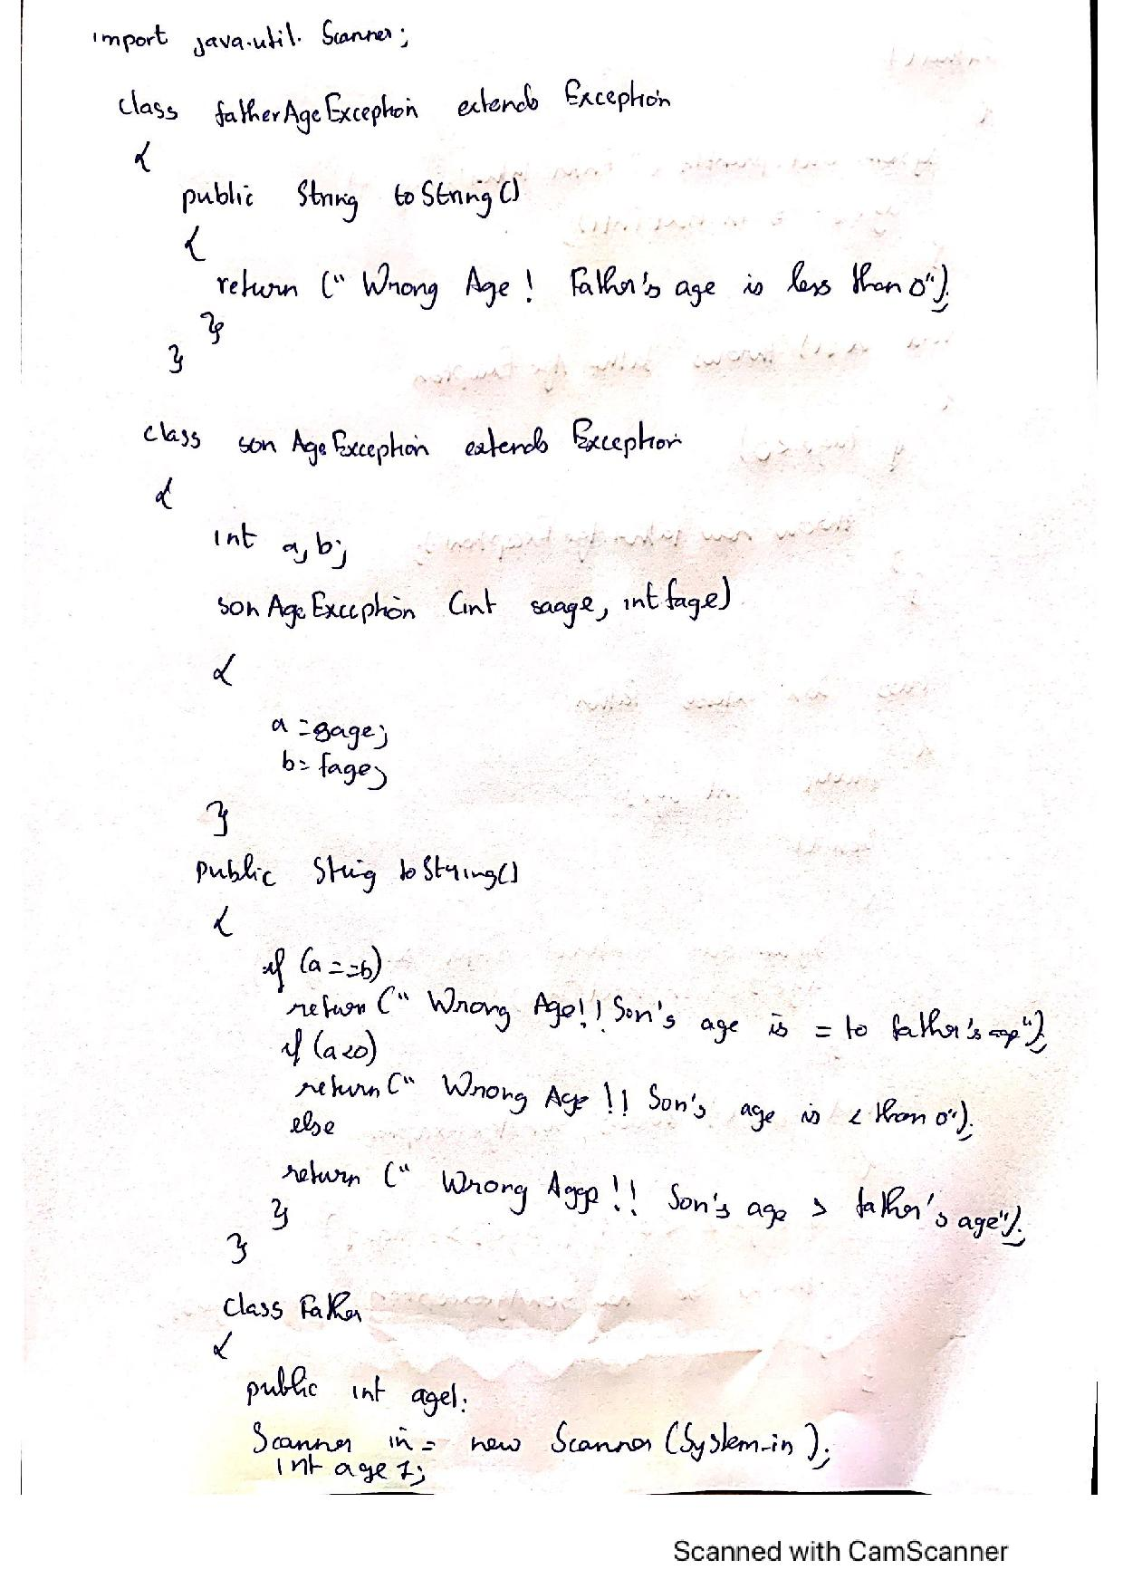

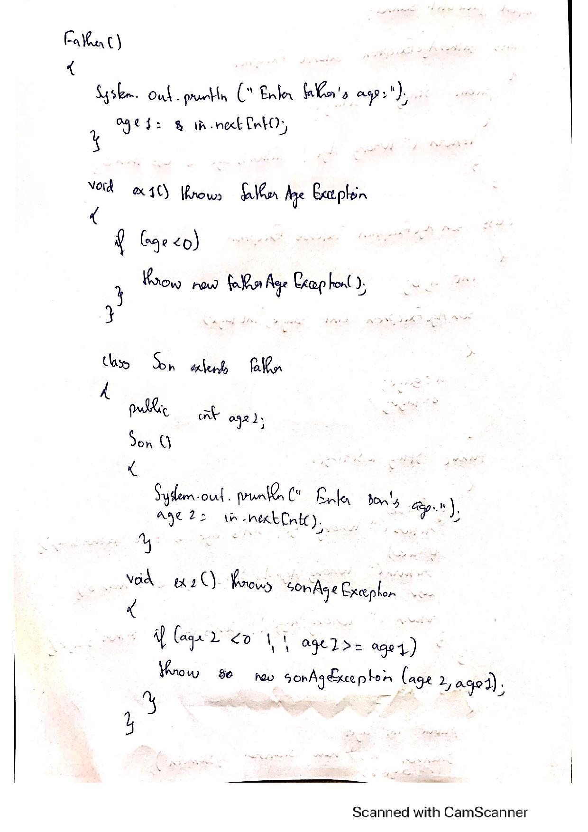

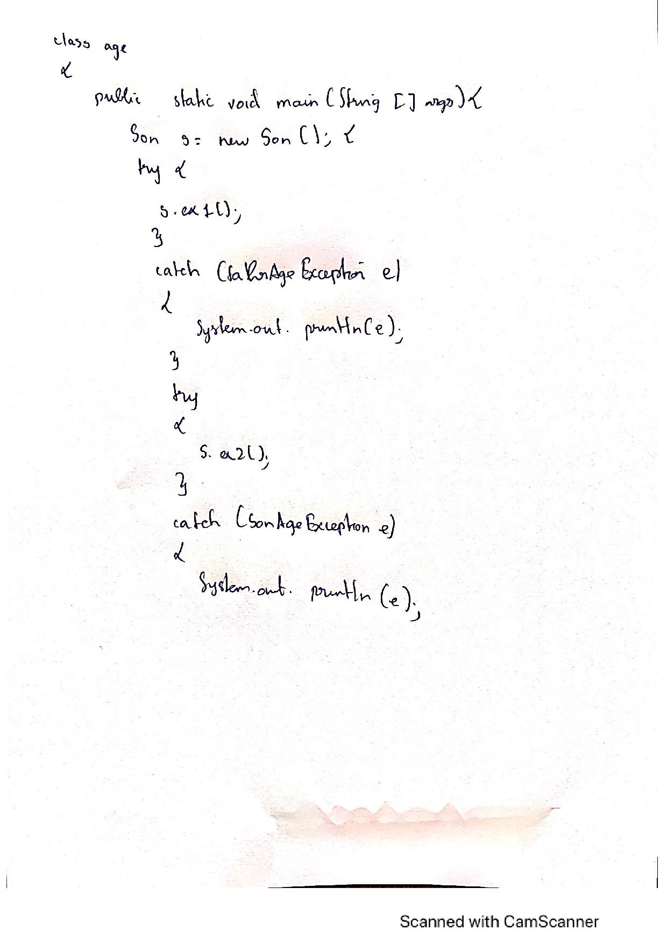

LAB -9

class NewThread implements Runnable

{

private String name;

private int interval;

private Thread t;

NewThread(String threadname,int interval)

{

this.name=threadname;

this.interval=interval;

t=new Thread(this,name);

t.start();

}

public void run()

{

try

{

for(int i=5;i>0;i--)

{

System.out.println("Thread --"+this.name);

Thread.sleep(this.interval);

}

}

catch(InterruptedException e)

{

System.out.println(name+"Interrupted");

}

}

}

class Multithread

{

public static void main(String args[])

{

new NewThread("BMS College Of Engineering",10000);

new NewThread("CSE",2000);

}

}

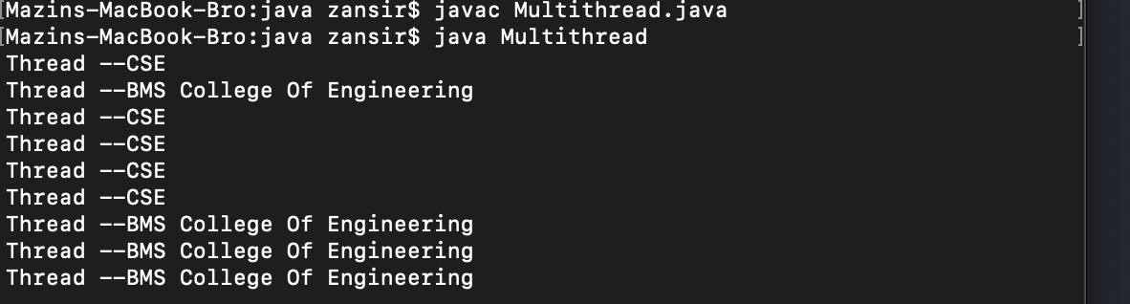

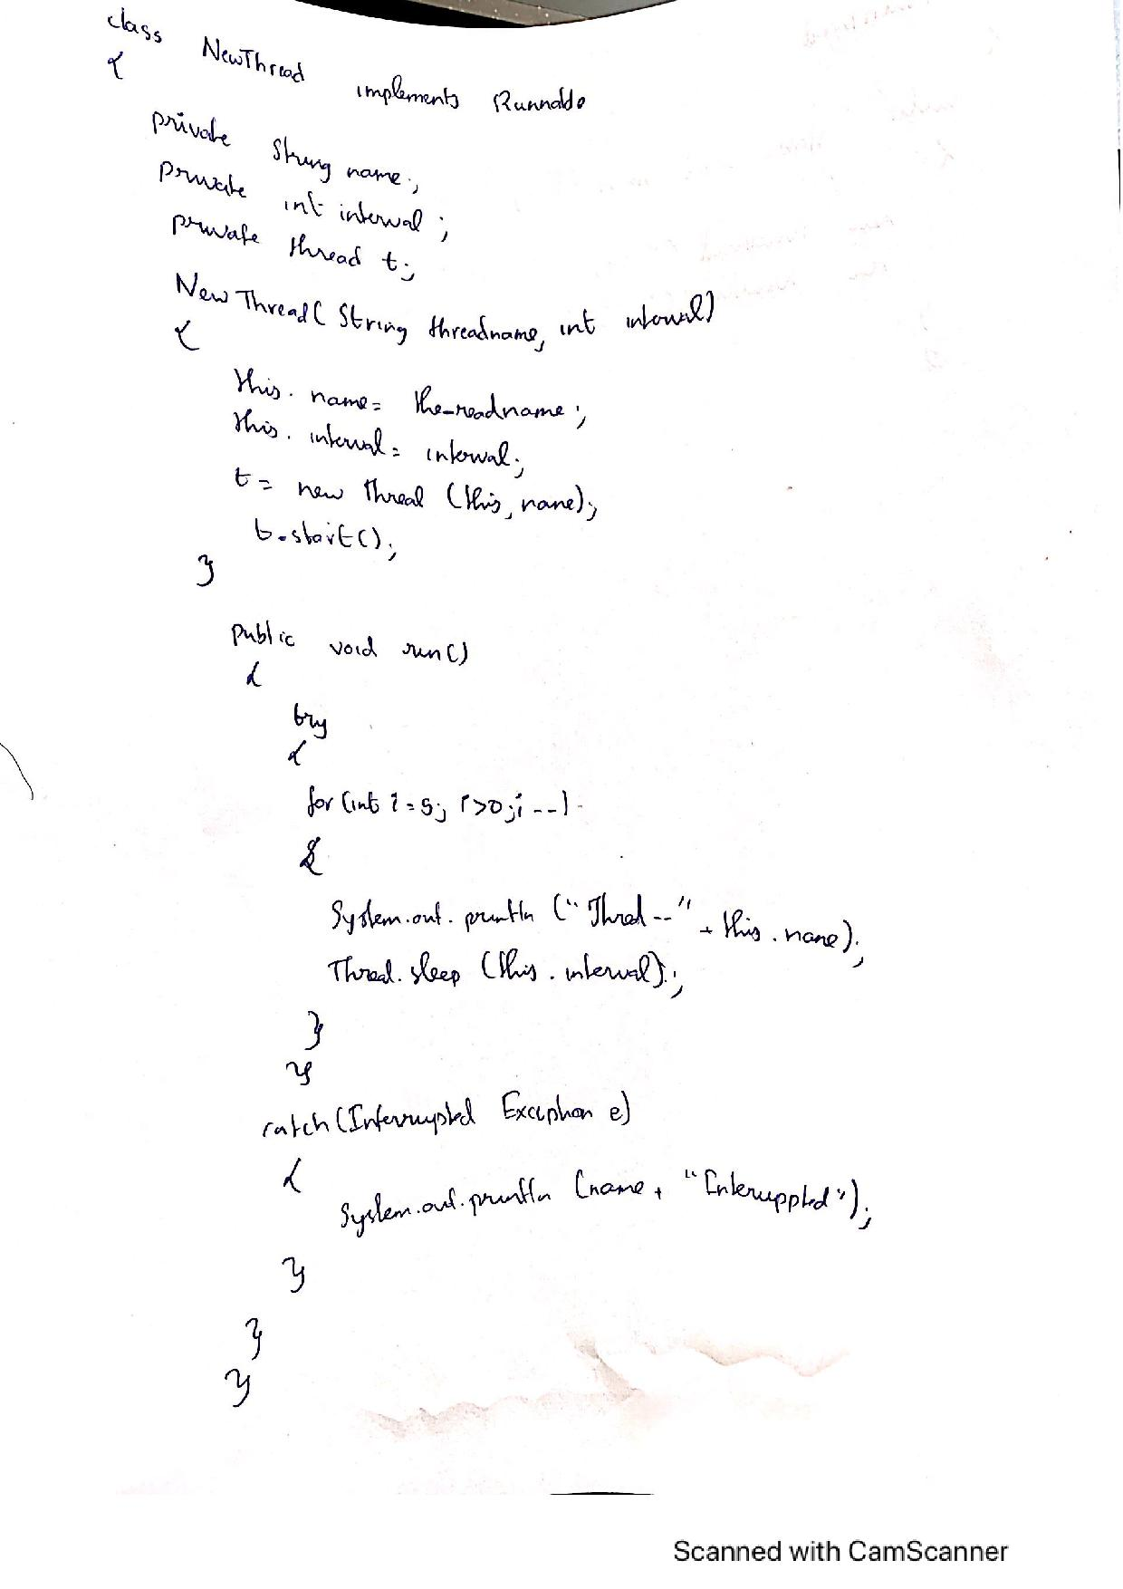

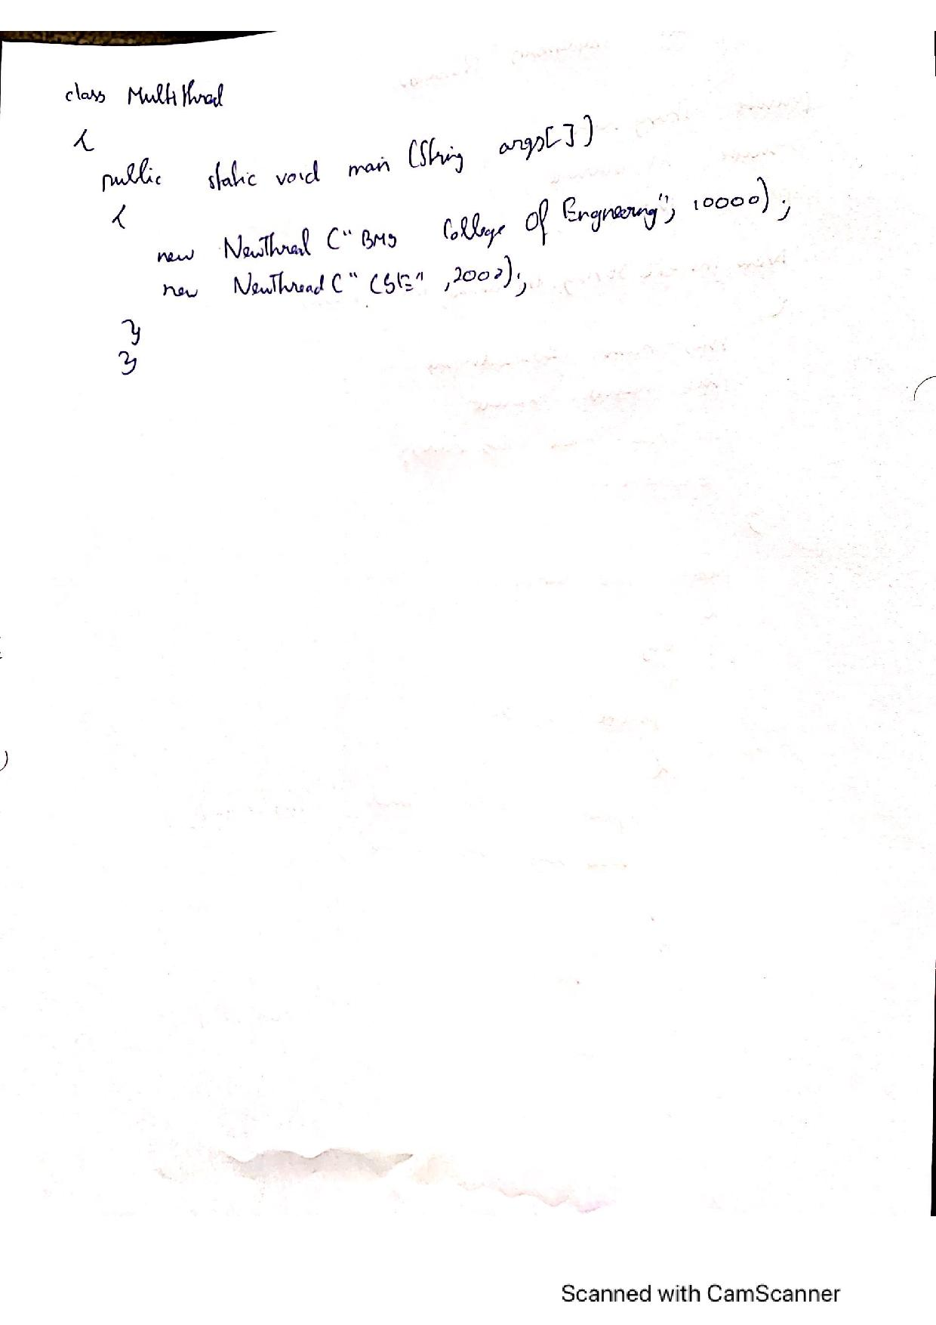

LAB 10

import java.awt.*;

import java.awt.event.*;

class DivisionInteger extends Frame implements ActionListener{

TextField num1TextField;

TextField num2TextField;

Button calculate;

int a,b;

float result;

String msg="Enter the numbers";

public DivisionInteger(){

setLayout(new FlowLayout());

calculate=new Button("Calculate");

num1TextField=new TextField(5);

Label num1Label=new Label("Number 1",Label.RIGHT);

num2TextField=new TextField(5);

Label num2Label=new Label("Number 2",Label.RIGHT);

add(num1Label);

add(num1TextField);

add(num2Label);

add(num2TextField);

add(calculate);

num1TextField.addActionListener(this);

num2TextField.addActionListener(this);

calculate.addActionListener(this);

addWindowListener(new MyWindowAdapter());

}

public void actionPerformed(ActionEvent ae){

try{

result=divideNumbers();

msg=("The result is "+result);

repaint();

}catch(NumberFormatException e){

msg="Number is not Integer."+e;

repaint();

}catch(ArithmeticException e){

msg="Divide By zero not Allowed."+e;

repaint();

}

}

public float divideNumbers(){

a=Integer.parseInt(num1TextField.getText());

b=Integer.parseInt(num2TextField.getText());

if(b==0){

throw new ArithmeticException();

}

return (float)a/b;

}

public void paint(Graphics g){

g.drawString(msg,50,100);

}

public static void main(String args[]){

DivisionInteger div=new DivisionInteger();

div.setSize(new Dimension(500,500));

div.setTitle("Division Calculater");

div.setVisible(true);

}

}

class MyWindowAdapter extends WindowAdapter{

public void windowClosing(WindowEvent event){

System.exit(0);

}

}

